SUBCOURSE EDITION
CM1207 4

MAINTENANCE OF THE
M12A1 PDDA

MAINTENANCE OF
THE M12A1 PDDA

Subcourse No. CM1207 Ed 4

US Army Chemical School
Fort McClellan, Alabama

8 Credit Hours

General

The Maintenance of the M12A1 PDDA subcourse is designed to teach the student how to maintain the M12A1 PDDA. In this subcourse, the student will learn the procedures for placing a new apparatus into operation, and the operator-level checks and services to be performed before, during, and after operation of the apparatus. The student also will learn operator-level and organizational-level troubleshooting and corrective maintenance on the M12A1 PDDA. The Subcourse is presented in four lessons, each corresponding to a terminal learning objective as indicated below.

Lesson 1: Describe the M12A1 PDDA and Preventive Maintenance Checks and Services Required for Placing the Apparatus Into Operation

TASK: Describe the M12A1 PDDA and preventive maintenance checks and services required for placing the apparatus into operation.

CONDITIONS: Given information about and illustrations of the M12A1 PDDA, special use, and the procedures for placing new equipment into operation, including unloading and unpacking, fueling, lubrication, test spraying cleaning and loading with supplies and equipment.

STANDARDS: Demonstrate competency of the task skills and knowledge by responding to the multiple-choice test covering the description of the M12A1 PDDA and preventive maintenance checks and services required for placing the apparatus into operation.

(This objective partially supports SM Task #031-507-1021, Load the Tank Unit with Water from a Natural Source; SM Task #031-507-1022, Pump Water Without Loading Tank from a Natural Source; SM Task #031-507-1023, Heat Water in Tank; SM Task #031-507-1024, Heat Water Drawn from a Natural Source; SM Task #031-507-1026, Meter Soap with Water; SM Task #031-507-1025, Meter Foam with Water; SM Task #031-509-

i

1020, Load, Blend, Agitate and Spray Decontaminants; SM Task #031-507-1019. Start and Stop the M12A1 PDDA; and SM Task #031-507-1017, Perform Operator Preventive Maintenance Checks and Services on M12A1 PDDA.)

Lesson 2: Describe Operator Preventive Maintenance Checks and Services for the M12A1 PDDA

TASK: Describe operator preventive maintenance checks and services for the M12A1 PDDA.

CONDITIONS: Given information about the checks and services performed by the operator before, during, and after operation on the pump-unit assembly, tank-unit assembly, personnel shower unit assembly, and M2 Water Heater.

STANDARDS: Demonstrate competency of the task skills and knowledge by responding to the multiple-choice test covering the checks and services performed by the operator on the pump-unit assembly, tank-unit assembly, personnel shower unit assembly, and M2 Water Heater before, during, and after operation.

(This objective partially supports SM Task #031-507-1021, Load the Tank Unit with Water from a Natural Source; SM Task #031-507-1022, Pump Water Without Loading Tank from a Natural Source; SM Task #031-507-1023, Heat Water in Tank; SM Task #031-507-1026, Meter Soap with Water; SM Task #031-507-1025, Meter Foam with Water; SM Task #031-509-1020, Load, Blend, Agitate and Spray Decontaminants; SM Task #031-507-1019, Start and Stop the M12A1 PDDA; and SM Task #031-507-1017, Perform Operator Preventive Maintenance Checks and Services on the M12A1 PDDA.)

Lesson 3: Describe Operator Corrective Maintenance on the M12A1 PDDA

TASK: Describe operator corrective maintenance on the M12A1 PDDA.

CONDITIONS: Given information about procedures for performing operator troubleshooting and operator corrective maintenance on the pump unit assembly, tank-unit assembly, personnel shower unit assembly, and M2 Water Heater, including subcomponents of these assemblies.

STANDARDS: Demonstrate competency of the task skills and knowledge by responding to the multiple-choice test covering the procedures for performing operator troubleshooting and operator corrective maintenance on the pump-unit assembly, tank-unit assembly, personnel shower unit assembly, and M2 Water Heater, including subcomponents of these assemblies.

ii

(This objective partially supports SM Task #031-507-1021, Load the Tank Unit with Water from a Natural Source; SM Task #031-507-1022, Pump Water Without Loading Tank from a Natural Source; SM Task #031-507-1023, Heat Water in Tank; SM Task #031-507-1024, Heat Water Drawn from a Natural Source; SM Task #031-507-1026, Meter Soap with Water; SM Task #031-507-1025, Meter Foam with Water, SM Task #031-509-1020, Load, Blend, Agitate and Spray Decontaminants; SM Task #031-507-1019, Start and Stop the M12A1 PDDA; and SM Task #031-507-1017, Perform Operator Preventive Maintenance Checks and Services on the M12A1 PDDA.)

Lesson 4: Describe Organizational Corrective Maintenance of the M12A1 PDDA

TASK: Describe organizational corrective maintenance of the M12A1 PDDA.

CONDITIONS: Given information about the procedures for performing organizational troubleshooting and organizational corrective maintenance on the pump-unit assembly, tank-unit assembly, personnel shower unit assembly, and M2 Water Heater, including subcomponents of these assemblies.

STANDARDS: Demonstrate competency of the task skills and knowledge by responding to the multiple-choice test covering the procedures for organizational troubleshooting and performing organizational corrective maintenance on the pump-unit assembly, tank-unit assembly, personnel shower unit assembly, and M2 Water Heater, including subcomponents of these assemblies.

(This objective partially supports SM Task #031-507-1021, Load the Tank Unit with Water from a Natural Source; SM Task #031-507-1022, Pump Water Without Loading Tank from a Natural Source; SM Task #031-507-1023, Heat Water in Tank; SM Task #031-507-1024, Heat Water Drawn from a Natural Source; SM Task #031-507-1026, Meter Soap with Water; SM Task #031-507-1025, Meter Foam with Water; SM Task #031-509-1020, Load, Blend, Agitate and Spray Decontaminants; SM Task #031-507-1019, Start and Stop the M12A1 PDDA; and SM Task #031-507-1017. Perform Operator Preventive Maintenance Checks and Services on the M12A1 PDDA.)

iii

TABLE OF CONTENTS

Page
Title Page i
Table of Contents iv
Administrative Instructions vi
Grading and Certification Instructions vi
Introduction to Maintenance of the M12A1 PDDA vii

Lesson 1: Describe the M12A1 PDDA and Preventive 1
Maintenance Checks and Services Required
for Placing the Apparatus into Operation

Learning Event 1: Describe the M12A1 PDDA 2
and Identify New-equip-
ment Services
Learning Event 2: Describe Services Re- 10
quired for Placing the Ap-
paratus into Operation
Practice Exercise 15
Answers to Practice Exercise 18

Lesson 2: Describe Operator Preventive Maintenance 19
Checks and Services for the M12A1 PDDA

Learning Event 1: Describe Operator Checks 20
and Services Required for
the Pump Unit
Learning Event 2: Describe Operator Checks 24
and Services Required for
the Tank-unit Assembly and
Personnel Shower Unit
Assembly
Learning Event 3: Describe Operator Checks 26
and Services Required for
the M2 Water Heater
Practice Exercise 28
Answers to Practice Exercise 30

Lesson 3: Describe Operator Corrective Maintenance 31
of the M12A1 PDDA

iv

Page

Learning Event 1: Describe Troubleshooting 32
the M12A1 PDDA by the
Operator
Learning Event 2: Describe Operator Correc- 36
tive Maintenance on the
Pump-unit Assembly
Learning Event 3: Describe Operator Correc- 43
tive Maintenance on the
Tank-unit Assembly, M2
Water Heater and Person-
nel Shower Unit Assembly
Practice Exercise 46
Answers to Practice Exercise 48

Lesson 4: Describe Organizational Corrective Main- 49
tenance of the M12A1 PDDA

Learning Event 1: Describe Troubleshooting 50
of the M12A1 PDDA at
Organizational Level
Learning Event 2: Describe Organizational 54
Corrective Maintenance of
the Pump-unit Assembly
Learning Event 3: Describe Organizational 64
Corrective Maintenance on
the Tank-unit Assembly,
Personnel Shower Unit
Assembly, and M2 Water
Heater
Practice Exercise 73
Answers to Practice Exercise 76

Posttest 1 PT1-1

Student Inquiry Sheet
ACCP Inquiry Sheet
Exam Return Envelope

v

***IMPORTANT NOTICE***
THE PASSING SCORE FOR ALL ACCP MATERIAL IS NOW 70%
PLEASE DISREGARD ALL REFERENCES TO THE 75% REQUIREMENT.

vi

Introduction

INTRODUCTION TO
MAINTENANCE OF THE M12A1 PDDA

The M12A1 PDDA is perhaps the single most important piece of equipment available for decontamination. In addition, the M12A1 PDDA can be used for fire-fighting deicing, and cleaning vehicles. But as with any piece of equipment the M12A1 PDDA is subject to breakdown. Downtime of this critical equipment can severely affect missions conducted in NBC environments. The proper use of maintenance procedures will limit breakdowns to an acceptable minimum. Also scheduling checks and services at recommended intervals will help insure equipment readiness.

In this subcourse, you will learn to identify components of and services required to place the M12A1 PDDA into operation. You will also learn a description of and how to perform operation and organizational maintenance.

In Lesson 1, you will learn a component description of the M12A1 PDDA. You will also learn what services are required when you receive a new M12A1 PDDA and the services required to put this equipment into operation.

In order to describe the M12A1 PDDA and understand the services required to place the apparatus into operation, you must be able to:

1. Describe the M12A1 PDDA and identify new equipment services.

2. Describe services required for placing the apparatus into operation.

In Lesson 2, you will learn a description of operator maintenance for the three main components of the M12A1 PDDA and their accessories.

In order to gain an understanding of operator preventive maintenance checks and services for the M12A1 PDDA, you must first be able to:

1. Describe operator checks and services required for the pump-unit assembly.

2. Describe operator checks and services required for the tank-unit assembly and personnel shower unit assembly.

3. Describe operator checks and services required for the M2 Water Heater.

vii

Introduction

In Lesson 3, you will learn about troubleshooting procedures and corrective maintenance of the M12A1 PDDA at the operator level

In order to describe organizational-level corrective maintenance of the M12Al PDDA, you must be able to:

1. Describe troubleshooting of the M12A1 PDDA at the organizational level.

2. Describe organizational corrective maintenance of the pump unit.

3. Describe organizational corrective maintenance on the tank-unit assembly, personnel shower unit assembly, and M2 Water Heater.

In Lesson 4, you will learn about troubleshooting procedures and corrective maintenance of the M12A1 PDDA at the organizational level.

In order to describe operator corrective maintenance of the M12A1 PDDA, you must be able to:

1. Describe troubleshooting the M12A1 PDDA at the operator level

2. Describe operator corrective maintenance on the pump-unit assembly.

3. Describe operator corrective maintenance on the tank-unit assembly, M2 Water Heater, and personnel shower unit assembly.

The information you will learn in these four lessons will give you an understanding of operator and organizational maintenance of the M12A1 PDDA. Read each lesson carefully, then do the practice exercise at the end of the lesson.

When you have completed a practice exercise, use the practice exercise answer page to check yourself. Review any questions you have missed before going on to the next lesson. Study the illustrations. They will assist you in understanding the material.

When you have completed all four lessons, review the material before proceeding to the posttest.

viii

Lesson 1

LESSON 1
DESCRIBE THE M12A1 PDDA
AND PREVENTIVE MAINTENANCE CHECKS
AND SERVICES REQUIRED FOR PLACING
THE APPARATUS INTO OPERATION

TASK

Describe the M12A1 PDDA and preventive maintenance checks and services required for placing the apparatus into operation.

CONDITIONS

Given information about and illustrations of the M12A1 PDDA, special use, and the procedures for placing new equipment into operation, including unloading and unpacking, fueling lubrication, test spraying, cleaning, and loading with supplies and equipment.

STANDARDS

Demonstrate competency of the task skills and knowledge by responding to the multiple-choice test covering the description of the M12A1 PDDA and preventive maintenance checks and services required for placing the apparatus into operation.

REFERENCES

TM 3-4230-209-12
TM 3-4230-209-20&P
TM 3-4410-201-12
TM 5-2805-259-14

1

Lesson 1/Learning Event 1

LEARNING EVENT 1:
DESCRIBE THE M12A1 PDDA AND
IDENTIFY NEW-EQUIPMENT SERVICES

The complete nomenclature for the M12A1 PDDA is: decontaminating apparatus, power-driven, skid-mounted, multipurpose, nonintegral 500-gallon, ABC-M12A1. For brevity, in this subcourse it will continue to be called the M12A1 PDDA.

The M12A1 PDDA consists of a pump-unit assembly, a tank-unit assembly with a personnel shower assembly, and an M2 Water Heater Assembly. These three items are shown in figure 1.

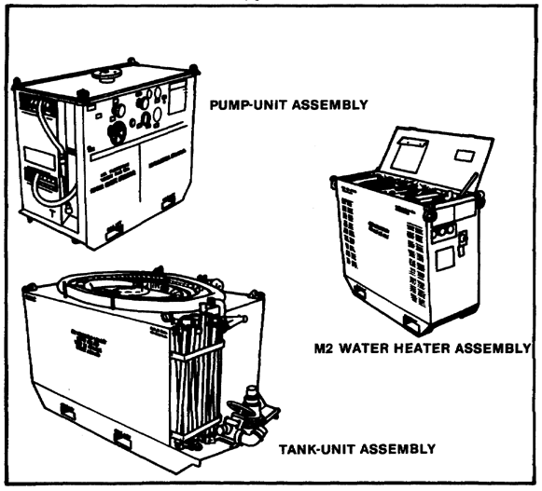
FIGURE 1. THREE MAJOR COMPONENTS OF THE
M12A1 PDDA.

2

Lesson 1/Learning Event 1

In this learning event, we will discuss the major components, special tools, and the procedures required for performing new-equipment services.

Pump-unit Assembly

The pump-unit assembly is a skid-mounted unit consisting of a frame assembly, cover panels, a gasoline engine, a fuel tank, prime-detergent tank plumbing, pump housing, a generator, a battery, two discharge hoses on two hose reels, a connector panel, a control panel, exhaust-pipe extensions, and a cover. A toolbox, which is used to store on-equipment material (OEM), is located between the two hose reels. A suction-hose connector and two discharge-hose connectors are on the connector panel at the back of the pump unit. A lifting eye with clevis is provided on top of each corner for picking up the pump-unit assembly. The canvas cover is provided to cover the pump-unit assembly when it is not in use. The two exhaust-pipe extensions are stowed on the tank-unit assembly. The extensions are attached to the exhausts of the engine when it is operating. The pump-unit assembly is shown in figure 2.

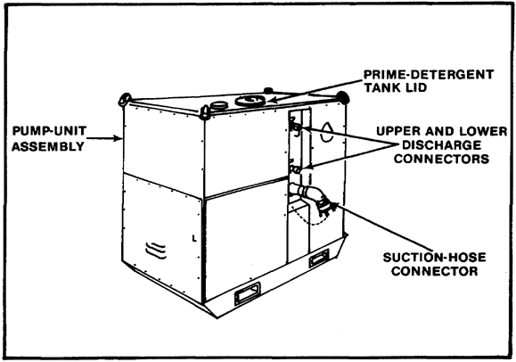
FIGURE 2. PUMP-UNIT ASSEMBLY.

The pump housing consists of a pump, a four-groove-driven pulley, a connector for suction-vacuum gage tubing and discharge-pressure gage tubing, a prime/eductor, piping, a discharge-pressure pipe, and a drain pipe.

3

Lesson 1/Learning Event 1

Tank-unit Assembly

The tank-unit assembly (figure 3 below and figure 5 on page 7) is used to store the water needed for the M12A1 PDDA. The tank is bolted to a skid. A hopper-blender assembly and the agitator in the tank are used to blend STB decontaminating agent and water.

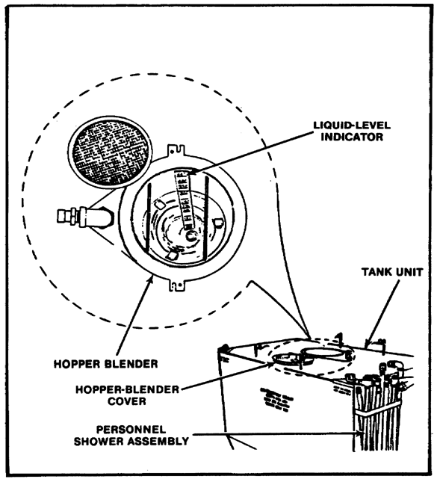
FIGURE 3. TANK-UNIT AND HOPPER-BLENDER
ASSEMBLY.

4

Lesson 1/Learning Event 1

The tank-unit assembly and personnel shower assembly consist of the tank, suction hose, foot valve, blender hose, tank-drain valve, hopper-blender assembly, and personnel shower. Four clevises and lifting eyes are provided for picking up the tank-unit assembly.

M2 Water Heater

The M2 Water Heater is used to heat water for equipment decontamination operations or personnel showers. The M2 Water Heater is shown in figure 4 on page 6. It consists of three main components: the fuel and ignition system, the combustion system, and the control system. The systems consist of removable panels, a control panel, a control box, a fuel-hose assembly, an electrical power-cable assembly, a water-hose assembly, a boiler assembly, a combustor assembly, two electrical motors, a magneto, a filter, and tools.

Special Tools

The following special tools are required by the operator to maintain the pump-unit assembly:

• A universal spanner wrench

• Two 15-inch adjustable wrenches

• An 8-inch flat-tip screwdriver

• A 9/16 by 5/8-inch double-head open-end wrench

• A pair of retaining ring pliers

• A V-belt tensiometer

• A collapsible pail

• A hand crank

• A pull rope

A pair of slip-joint pliers, an eight-inch adjustable wrench, and a flat-tip screwdriver are supplied with the M2 Water Heater.

5

Lesson 1/Learning Event 1

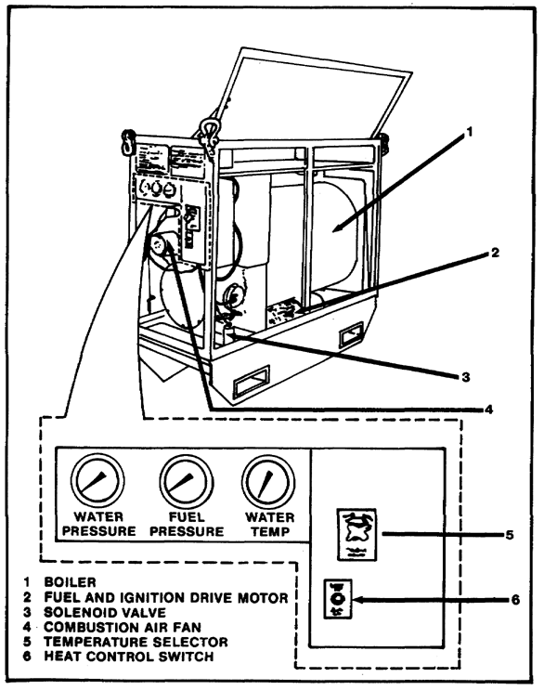
FIGURE 4. M2 WATER HEATER AND CONTROL PANEL.

6

Lesson 1/Learning Event 1

New-equipment Services

When your organization receives a new M12A1 PDDA that is packed in a wooden crate, you should notify direct support maintenance personnel. The M12A1 PDDA is received on three skids in a dry and unserviced condition. The battery is not filled with electrolyte. The drive-belt tension is released, the fuel tank interior surface is coated with OE-30 oil and is empty, and the oil is drained from the gasoline engine. All pipe openings are sealed with caps or with pressure-sensitive adhesive tape. The gages on the control panels are taped. The interior surfaces of the pump, tanks, and all piping are coated with a preservative lubricant. If possible, the operating crew will assist organizational-maintenance personnel in unloading and servicing. Remove the cover panels as necessary to inspect that the equipment is satisfactory. Use figure 5 to check that the tank unit is satisfactory.

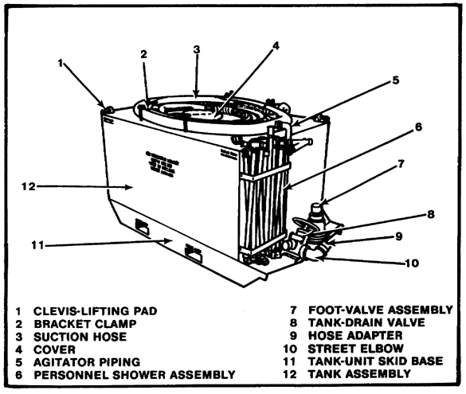
FIGURE 5. TANK-UNIT ASSEMBLY UNPACKED.

7

Lesson 1/Learning Event 1

Unpacking. See that the equipment is complete by checking it against the packing list for each skid. See that the special tools and accessories are with the equipment and that one hose-reel crank handle is in the toolbox. Insure all publications are present. See that all markings comply with AR 746-1. Check that the metal-strap shipping-mount assembly in the pump-unit assembly was removed by direct support maintenance personnel. The shipping-mount assembly connects between the engine flywheel housing and the skid. Check that the three engine shock mount pads are installed between the front and rear engine mounts and the top of the front and rear channel assemblies. If they are missing or are improperly installed, notify direct support maintenance personnel. Check that the tachometer cable, hose-reel pillow blocks, and the fuel-hose assembly have not vibrated loose during transit.

Procedures for Unloading and Preparation for Operation

Unloading. Remove the three unpackaged skids from the carrier. Avoid damaging the equipment. Use suitable equipment to lift the three skids from the carrier or to tow the skids to the receiving dock.

Remove all preservative compounds and tape from the equipment. If necessary, use dry-cleaning solvent (SD) to remove residual material. Some pump-unit assemblies have preservative oil in the sediment bowl. Before filing the fuel tank with gasoline, clean the sediment bowl.

CAUTION

Do not allow preservative oil to enter the gasoline engine carburetor.

WARNING

Do not allow smoking when filling the fuel tank with gasoline. Also do not permit open flame, sparks, or heated objects in the area.

Preparation for Operation. Use the following steps to prepare the M12A1 PDDA for operation.

Step 1. Perform the before-operation services for the M12A1 PDDA and for the engine, TM 5-2805-259-14.

Step 2. Lubricate the M12A1 PDDA using LO-3-4230-209-12 and LO-5-2805-259-12.

Step 3. Load 200 gallons of water into the tank-unit assembly. Watch for leaks at pipe connections and valves.

8

Lesson 1/Learning Event 1

Step 4. Check the oil gage rod to insure that the engine is full of oil and that the engine crankcase is filled. Operate the valves to check for smoothness of operation.

Step 5. Lubricate the M12A1 immediately after performing test spraying.

NOTE

A used M12A1 PDDA is serviced in the same manner as a new one. Examine used equipment for signs of wear, damage, or missing parts. Correct deficiencies if authorized or notify maintenance personnel.

9

Lesson 1/Learning Event 2

LEARNING EVENT 2:
DESCRIBE SERVICES REQUIRED FOR
PLACING THE APPARATUS INTO OPERATION

Lubrication

The most important and most often overlooked aspect of servicing is lubrication. Lubricating the M12A1 PDDA must be done at specific intervals. Lubrication cannot be done as a half-hearted attempt to fulfill a requirement. The specified lubricant, in the right mount, applied at the correct location, is necessary for proper servicing. Applying lubricant in the correct amount is an important part of this concern. An insufficient amount of lubricant will likely lead to early component failure. On the other hand, too much lubricant (especially in areas of non-vented bearings and seals), will cause excessive pressure to build, creating binding and early component failure.

The only sure means of correctly lubricating the M12A1 PDDA is to use the appropriate lubrication orders. A lubrication order (LO) is a pictorial diagram displaying the equipment to be lubricated, exact lubrication points, which lubricant to use, and at what interval this service must be performed.

The M12A1 PDDA uses two lubrication orders. LO-3-4240-209-12 applies to the M12A1 PDDA and LO-5-2805-259-12 applies specifically to the gasoline engine. LO-3-4230-209-12 (figure 6 on pages 11 and 12) shows the intervals of lubrication as daily, weekly, and monthly. These intervals may be lessened based on special conditions. These conditions are abnormal operation, severe operating conditions, or when lubricants are found to be contaminated Additionally, during long periods of inactivity (such as storage), lubrication intervals may be extended as long as adequate preservation is ensured.

Fueling Procedures for the M12A1 PDDA

The M12A1 PDDA has two separate fuel requirements. Fuel is used by the gasoline engine and the M2 Water Heater. Procedures for fueling both components are described below.

Fueling the Gasoline Engine. Fueling the gasoline engine will be performed by the following method.

Step 1. Wipe off the dirt around the filter-pipe opening and the fuel-tank cap. Remove the cap by slowly turning it counterclockwise until a stop is felt. Then press down on the cap to allow the prongs on the cap-pressure plate to pass under the projections on the filler-pipe neck ramp.

10

Lesson 1/Learning Event 2

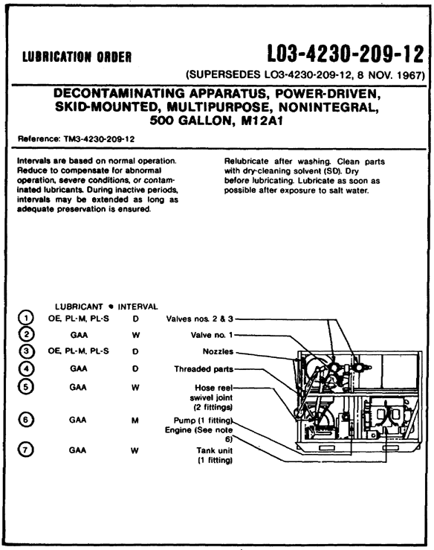
FIGURE 6. LUBRICATION ORDER (SHEET 1 OF 2).

11

Lesson 1/Learning Event 2

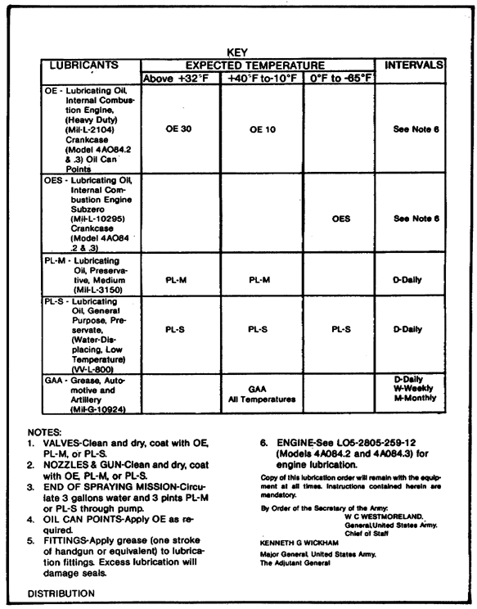
FIGURE 6. LUBRICATION ORDER (SHEET 2 OF 2), CONTINUED.

12

Lesson 1/Learning Event 2

Step 2. Fill the fuel tank until the fuel is approximately one inch below the filler neck.

Step 3. Insure that the vent inside the cap is in the open position. Push the filler sleeve down. Place the cap on the filler neck and turn the cap until a stop is felt. Press down on the cap and turn clockwise to lock it.

WARNING

Do not allow smoking when filling the fuel tank with gasoline. Also do not permit open flame, sparks, or heated objects in the area.

CAUTION

While filling the tank with fuel, be sure that the dispenser-hose nozzle on the container is clean and that the nozzle on the container contacts the filler neck on the sleeve to carry off the static electricity. Do not overfill the fuel tank; a void for fuel expansion must be provided.

Fueling the M2 Water Heater. Fueling the M2 Water Heater will be done using different procedures. The M2 Water Heater does not have an integral fuel tank and must rely on an auxiliary fuel source. Use the following steps to fuel the M2 Water Heater.

WARNING

See that the HEATER/CONTROL switch is in the PURGE-ON position before proceeding.

Step 1. Remove the fuel-hose assembly (consisting of a fuel-supply hose, fuel-return hose, fuel-tank hose, fuel-tank plug, and ground wire) from the storage compartment.

Step 2. Connect the fuel-tank plug into a five-gallon gasoline can that is full of fuel. Screw the fuel-tank plug down loosely.

13

Lesson 1/Learning Event 2

NOTE

Any other suitable container (such as a 55-gallon drum) may be used. Make certain that the open end of the fuel tank hose is low in the fuel container so that the maximum amount of fuel can be used.

Step 3. Remove the cap from the quick-disconnect coupling-half hose connector at the skid-assembly base. Connect the fuel-return hose quick- disconnect coupling half to the connector. Pull on the connected fuel-return hose to make certain that it is securely fastened.

Step 4. Remove the cap from the fuel-supply hose connector at the skid-assembly base. Connect the fuel-supply hose quick-disconnect coupling half to the fuel-supply connector. Pull on the connected fuel-supply hose to make certain that it is securely fastened.

Loading Supplies and Protective Clothing

Load supplies in the quantities needed on the vehicle or trailer being used to transport the M12A1 PDDA. See that protective clothing for the five-man crew performing decontaminating operations is available and ready to use.

Test Spraying

Test spraying will be done as the last procedure in preparing the M12A1 PDDA for operation. Use the following steps to perform test spraying.

Step 1. Fill the tank-unit assembly with 200 gallons of water. Remove the cover and check the water level on the tank liquid-level indicator. Inspect all pipe connections and valves for signs of leakage.

Step 2. Discharge half of the water in the tank through the gun assemblies and half of the water through the showers. Inspect the discharge piping and hoses for signs of leakage. For new equipment, water flowing through the pump unit will clean preservative lubricant from inside the piping and valves. Inspect for unusual noises or erratic operation of the pump. See that the pump discharge pressure gage is indicating 60 -120 psi during pump operation.

Step 3. After test spraying, flush and drain the ABC-M12A1 decontaminating apparatus immediately.

14

Lesson 1/Practice Exercise

PRACTICE EXERCISE FOR LESSON 1

Instructions

You have just finished reading the instructional material for Lesson 1. This lesson covered a description of the M12A1 PDDA, new-equipment services, and the services required for placing the apparatus into operation. It is now time to check your understanding of the lesson. This is done by completing the practice exercise below. All of the questions are multiple-choice and are intended to measure your understanding of the procedures used in performing the task. There is only one correct answer to each question. Try to answer all of the questions without referring to the lesson material.

When you have completed all of the questions, turn the page and check your answers against the correct responses. Each correct response is referenced to specific portions of the lesson material so that you can review any questions you have missed or do not understand. When you have completed your review, continue to the next lesson.

1. Which of the following conditions would increase the lubrication intervals?

a. Abnormal operation
b. Contaminated lubricants
c. Severe operating
d. Inactive periods

2. The battery on a new M12A1 PDDA is received in what condition?

a. Not filled with electrolyte
b. Filled with electrolyte and must be charged
c. Filled and charged
d. No specified condition

3. How will the operator determine the standard intervals of component servicing?

a. Ask the supervisor.
b. Service only when excessive noise is heard.
c. Look under the operating instructions on the components.
d. Refer to the lubricating order.

15

Lesson 1/Practice Exercise

4. Which component of the M12A1 PDDA requires an external fuel supply?

a. Gasoline engine
b. Pump unit
c. Charging system
d. M2 Water Heater

5. Which one of the following assemblies is NOT a component of the M12A1 PDDA?

a. Pump-unit assembly
b Tank-unit assembly
c. 50-GPM Pump
d. M2 Water Heater Assembly

16

Lesson 1/Practice Exercise Answers

ANSWER SHEET FOR PRACTICE EXERCISE

Lesson 1

1. d (Refer to Learning Event 2)
2. a (Refer to Learning Event 1)
3. c (Refer to Learning Event 2)
4. d (Refer to Learning Event 2)
5. c (Refer to Learning Event 1)

18

Lesson 2

LESSON 2
DESCRIBE OPERATOR PREVENTIVE
MAINTENANCE CHECKS AND SERVICES
FOR THE M12A1 PDDA

TASK

Describe operator preventive maintenance checks and services for the M12A1 PDDA.

CONDITIONS

Given information about and checks and services performed by the operator before, during and after operation on the pump-unit assembly, tank-unit assembly, personnel shower unit assembly, and M2 Water Heater.

STANDARDS

Demonstrate competency of the task skills and knowledge by responding to the multiple-choice test covering the checks and services performed by the operator on the pump-unit assembly, tank-unit assembly, personnel shower unit assembly, and M2 Water Heater before, during and after operation.

REFERENCES

TM 3-4230-209-20&P
TM 3-4240-209-12
TM 3-4410-201-12
TM 5-4250-256-14

19

Lesson 2/Learning Event 1

LEARNING EVENT 1:
DESCRIBE OPERATOR CHECKS AND
SERVICES REQUIRED FOR THE PUMP UNIT

The most important aspect of operators maintenance is preventive maintenance. Preventive maintenance is the systematic care, servicing, and inspection of equipment to prevent the occurrence of trouble, reduce downtime, and assure the equipment is serviceable. As with any piece of military equipment the operator is the key to the prevention of trouble. To insure this, operator maintenance is performed on a daily basis.

Operation Services on the Pump Unit

The operator inspects, records, and reports all deficiencies that are not correctable at the operator preventive maintenance level to organizational preventive maintenance using DA Form 2404. There are three phases of operator maintenance for the M12A1 PDDA. These phases are before-, during-, and after-operation services. In this learning event we will discuss which components of the pump unit are serviced during each phase of operator maintenance.

Before-operation Services. Use the following steps to perform before-operation services on the pump unit.

Step 1. Insure that appropriate Technical Manuals (TMs), Lubrication Orders (LOs), and Modification Work Orders (MWOs) that apply are present. In the canvas pouch on the pump-unit cover panel.

Step 2. Remove the quick-release panels from the pump unit, inspect for loose, missing, or obviously damaged hardware. Where necessary, tighten hardware and connections. See that the wiring or other objects do not obstruct moving parts. See that parts in the pump-unit assembly have been properly lubricated.

Step 3. Check the battery for obvious defects and damages. Insure the cables are properly attached. Inspect the water level in the battery cells and add distilled water if needed. Clean the battery terminals if corroded. A cut-away view of the battery is shown in figure 7 on page 21.

Step 4. Check the pump and generator drive belts for wear, breaks, or fraying. Using the V-belt tensiometer, check for proper tension (five to seven pounds) at 3/8-inch deflection. Adjust if necessary.

Step 5. Inspect the fuel filter beneath the fuel tank for dirt, water, or sediment. Check that the finger nut on the sediment bowl is open. Check that the fuel tank has sufficient gasoline. Check for leaks.

20

Lesson 2/Learning Event 1

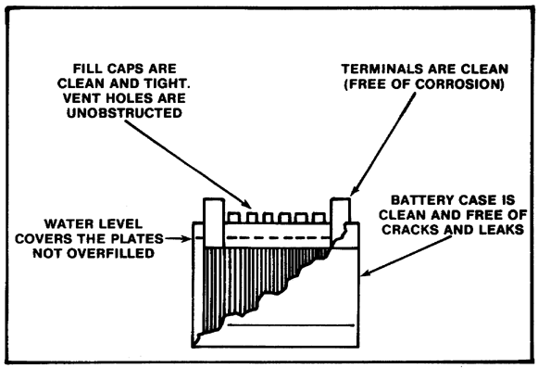
FIGURE 7. PROPERLY MAINTAINED BATTERY (CUT-
AWAY VIEW).

Step 6. Check that the oil level in the crankcase is satisfactory: add oil if necessary. Set the air control handle located at the bottom of the crankcase at the rear engine mount. The down position is the normal operation position when the temperature is above 0° F. Check that the choke operates smoothly by pulling out and allowing the spring-loaded choke to return. Insure that connections are properly fastened. Insure the valves are operating freely. Close all valves, including the pump-drain valve.

Step 7. Check that a gun assembly is on each of the discharge hoses. Make sure the gun handle operates the valve. Close the valves. Check all hoses for damage, and worn, broken, or damaged threads on the swivel coupling or cuts that could cause leaks.

Step 8. If the M2 Water Heater is used, see that the motor, pump, and magneto all turn freely together. Check that the fan is not blocked and turns freely.

Step 9. If the M2 Water Heater is used, check the electrical power cable for cracks, deterioration, bare or frayed wire, and kinks. Set the voltage regulator switch on the pump-unit control panel to OFF before plugging the electrical power cable into the pump unit.

21

Lesson 2/Learning Event 1

During-operation Services. Use the following steps to perform during-operation services on the pump unit.

Step 1. Check that the gages and tachometer work and are reading correctly:

• Vacuum Gage: 0 - 15 inches
• Pressure Gage: 60 - 120 psi
• Oil Pressure Gage: 0 - 60 psi
• Fuel Quantity Gage:
• Tachometer: 3850 RPM or less

CAUTION

Do not operate the pump for more than two minutes with a 0 pressure indication. If more time is needed to correct the fault shut down.

Step 2. Check for fuel leaks around the fuel tank, fuel lines, and carburetor areas.

Step 3. Check the engine for oil leaks. Check for unusual noises or any abnormal operation during the idling period. The engine should be crisp and evenly timed Observe the engine exhaust for unusual or excessive smoke. See that the engine responds smoothly to the throttle.

Step 4. Check for leaks in the pump pipes, and valves.

Step 5. Check that the prime-detergent tank has liquid in it while valve No. 4 is open. Close valve No. 4 after the pump is primed and operating.

Step 6. Check that no leakage occurs when the gun assembly is turned off under pressure.

Step 7. Check that the nozzles work without leaks.

Step 8. Check all hoses and couplings for leaks.

Step 9. During M2 Water Heater operation, check that the pump and fan motors are working.

Step 10. During M2 Water Heater operation, check for leaks from the pump, filter, piping, valves, and hose connections while operating the heater control switch in the PURGE-ON mode. Shut down if leak is found and repair it, if possible.

22

Lesson 2/Learning Event 1

Step 11. During M2 Water Heater operation, see that the gages work and are reading correctly:

• Water Pressure Gage: 60 - 120 psi
• Fuel Pressure Gage: At start-up only, 60 - 75 psi, depending on fuel type. During operation, it may be lower or higher.
• Water Temperature Gage: 49 F. - 190° F.

Step 12. Check the pump for leakage, unusual noises, and vibrations. Drain, flush, and clean. Lubricate as appropriate.

After-operation Services. Use the following steps to perform after-operation services on the pump unit.

Step 1. Lubricate the valves as appropriate. Clean if needed and replace caps. Open the pump-drain valve.

Step 2. See that the tools and accessories are present, cleaned, and stored.

Step 3. Install the cover panels and all canvas covers.

23

Lesson 2/Learning Event 2

LEARNING EVENT 2:
DESCRIBE OPERATION CHECKS
AND SERVICES REQUIRED FOR
THE TANK-UNIT ASSEMBLY AND
PERSONNEL SHOWER UNIT ASSEMBLY

As with the pump-unit assembly, the operator will perform before-, during-, and after-operation maintenance on the tank-unit assembly and the personnel shower unit assembly. In this learning event we will discuss which components of the tank-unit assembly and the shower unit assembly are serviced during each phase of operator maintenance.

Before-operation Services

Use the following steps to perform before-operation services on the tank-unit assembly and the shower unit assembly.

Step 1. Check for foreign objects or sediment in the tank. See that the exterior of the tank-unit assembly is clean. Clean if necessary. Close the tank drain valve and fill the tank with water. Check for leaks.

Step 2. Check that the hoses are free of damage or cuts. Make sure there are gaskets in the couplings while connecting hoses to appropriate connections. Replace gaskets, if necessary.

Step 3. Check the hopper-blender for obvious damage or foreign material plugging the bottom mixer. See that the strainer is serviceable.

Step 4. Check the foot valve for damage, corrosion, or blockage, and that it is securely mounted to the skid base.

Step 5. Check that the drain valve operates freely and has been lubricated.

Step 6. Check the shower unit for the following:

• All sections are complete and stowed properly in brackets.
• Threaded end and coupling fittings are not burred or damaged.
• Cleanliness of pipes, spray holes, and the sediment strainer.
• Ease of assembly (threaded connections).

24

Lesson 2/Learning Event 2

During-operation Services

Use the following steps to perform during-operation services on the tank-unit assembly and the shower unit assembly.

Step 1. Check, only when slurry is used, that the hopper-blender is not clogged and functions properly.

Step 2. Check for leaks and loose hose connections.

Step 3. Adjust the shower spray angle by turning the pipes.

Step 4. Monitor the personnel shower unit strainer screen and holes for stoppage and clean any plugged holes or screen.

After-operation Services

Use the following steps to perform after-operation services on the tank-unit assembly and the shower unit assembly.

Step 1. Drain and clean the tank-unit assembly. If the equipment has been used to pump slurry or chemicals, flush plumbing with water to prevent hardening of liquids or sticking valves.

Step 2. Lubricate if necessary.

25

Lesson 2/Learning Event 3

LEARNING EVENT 3:
DESCRIBE OPERATOR CHECKS AND
SERVICES REQUIRED FOR THE M2 WATER HEATER

The operator is required to perform operator checks and services on the M2 Water Heater. In this learning event we will discuss the procedures necessary to perform before-, during-, and after-operation services to the heater.

NOTE

The M12A1 PDDA unit must be in operation.

Before-operation Services

Use the following steps to perform before-operation services on the M2 Water Heater.

Step 1. Remove the side quick-release panels. Inspect for loose or missing hardware. Where necessary, tighten hardware or connections. See that the wiring or other objects do not obstruct any moving parts. Check for obvious damage to the boiler.

NOTE

Do NOT replace the side panels until after establishing water circulation through the boiler and operating the heater control switch in the PURGE-ON mode in order to check for water and fuel leaks with the system pressurized.

Step 2. Check that the controls and instruments are in good condition. Set the heater control switch to PURGE-ON. See that the gages work and are reading correctly:

• Water Pressure Gage: 60- 120 psi
• Fuel Pressure Gage: At START UP only, 60 - 75 psi, depending on fuel type. During operation, it may be lower or higher. The M2 Water Heater uses multifuel. The fuel pressure for the different fuels are gasoline - 75 psi, JP-4 fuel - 75 psi, kerosene - 70 psi, and diesel fuel- 60 psi.

26

Lesson 2/Learning Event 3

NOTE

If gasoline is being used to power the boiler, pour No. 2 diesel fuel oil (one pint per five gallons of gasoline) into the fuel container to prevent "freezing" of the fuel pump.

• Water Temperature Gage: 40° F. - 190° F.

Step 3. Make visual inspections of hoses and fuel lines for leaks.

During-operation Services

Use the following steps to perform during-operation services on the M2 Water Heater.

Step 1. Check the fuel lines and fuel filter shell for leaks. Check the boiler and water connections for steam and water leakage. Stop operation if a fuel leak is detected.

Step 2. Monitor fuel supply.

WARNING

Fuel leaks occurring during operation require the operator to stop the M2 Water Heater immediately. Failure to do so may result in fire and injury to personnel.

Step 3. Visually inspect the water pressure, fuel pressure, and water temperature gages for normal operation.

After-operation Services

Use the following steps to perform after-operation services on the M2 Water Heater.

Step 1. Clean the M2 Water Heater. Only run clear water through the M2 Water Heater.

Step 2. Lubricate as required.

27

Lesson 2/Practice Exercise

PRACTICE EXERCISE FOR LESSON 2

Instructions

You have just finished reading the instructional material for Lesson 2. This lesson covered the procedures for performing operator-level checks and services on the pump unit tank, unit and personnel shower unit assembly, and the M2 Water Heater. It is now time to check your understanding of the lesson. This is done by completing the practice exercise below. All of the questions are multiple-choice and are intended to measure your understanding of the procedures used in performing the task. There is only one correct answer to each question. Try to answer all of the questions without referring to the lesson material.

When you have completed all of the questions, turn the page and check your answers against the correct responses. Each correct response is referenced to specific portions of the lesson material so that you can review any questions you have missed or do not understand. When you have completed your review, continue to the next lesson.

1. How would the operator adjust the spray angle of the shower assembly during operation?

a. Adjusting valve No. 4
b. Adding more shower sections
c. Increasing the water pressure
d. Turning the pipes

2. Which gage would show a reading of 60 - 75 psi during start-up only?

a. Fuel pressure
b. Tank level
c. Water pressure
d. Water temperature

3. What would require the operator to stop operations?

a. High water pressure
b. Low water pressure
c. A fuel leak
d. High feel pressure

28

Lesson 2/Practice Exercise

4. What must be done on the control panel prior to filling the tank with water?

a. Open valve No. 1
b. Close valve No. 1
c. Open valve No. 4
d. Close valve No. 4

5. The operator will record deficiencies by using which form?

a. DA Form 1981
b. DA Form 2404
c. DA Form 2407
d. DA Form 2408-1

29

Lesson 2/Practice Exercise Answers

ANSWER SHEET FOR PRACTICE EXERCISE

Lesson 2

1. d (Refer to Learning Event 2)
2. a (Refer to Learning Event 3)
3. c (Refer to Learning Event 3)
4. d (Refer to Learning Event 2)
5. b (Refer to Learning Event 1)

30

Lesson 3

LESSON 3
DESCRIBE OPERATOR CORRECTIVE
MAINTENANCE ON THE M12A1 PDDA

TASK

Describe operator corrective maintenance on the M12A1 PDDA.

CONDITIONS

Given information about procedures for performing operator troubleshooting and operator corrective maintenance on the pump-unit assembly, tank-unit assembly, personnel shower unit assembly, and the M2 Water Heater, including subcomponents of these assemblies.

STANDARDS

Demonstrate competency of the task skills and knowledge by responding to the multiple-choice test covering the procedures for performing operator corrective maintenance on the pump-unit assembly, tank-unit assembly, personnel shower unit assembly, and the M2 Water Heater, including subcomponents of these assemblies.

REFERENCES

TM 3-4230-209-12
TM 3-4230-209-20&P
TM 3-4410-201-12
TM 5-2805-259-14

31

Lesson 3/Learning Event 1

LEARNING EVENT 1:
DESCRIBE TROUBLESHOOTING
THE M12A1 PDDA BY THE OPERATOR

Troubleshooting is a process by which a problem is identified, diagnosed as to the probable cause, and then a corrective action is decided on. In order to perform troubleshooting on the M12A1 PDDA, the operator must first learn how to identify a problem. A problem exists when one or more of the following conditions are present.

• Failure to start
• Failure to function properly
• Excessive operating noise
• Overheating
• Excessive vibration

Once a problem is identified, the next step is for the operator to identify the most probable cause of the malfunction. This phase of troubleshooting requires a lot of common sense. For example: if the engine fails to start the operator would restrict the inspection for the probable cause to the engine and directly related components.

After identifying the most probable cause of the problem, the operator must then decide on the proper corrective action to perform. A corrective action is a service or repair necessary to eliminate the problem. In addition, the operator must decide whether this action can be accomplished at the operator level or must be referred to a higher category of maintenance.

To assist the operator in making these determinations, a troubleshooting table is shown in figure 8 on pages 33 through 35. This table illustrates the malfunction, probable causes of the malfunction, the corrective action required, and at what level the corrective action can be performed. Use this table whenever you need to troubleshoot the M12A1 PDDA.

32

Lesson 3/Learning Event 1

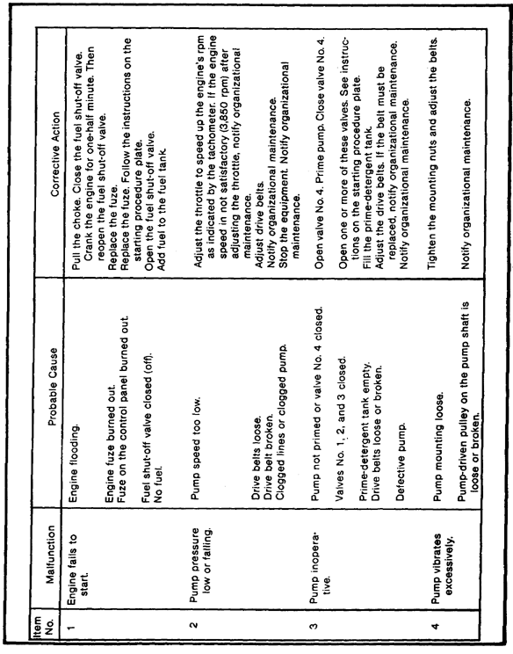
FIGURE 8. TROUBLESHOOTING TABLE.

33
Lesson 3/Learning Event 1

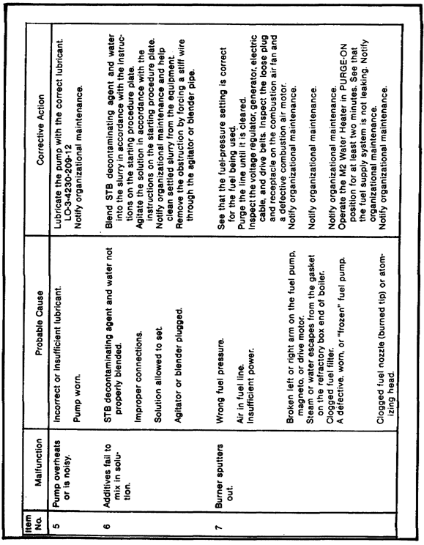
FIGURE 8. TROUBLESHOOTING TABLE, CONTINUED.

34
Lesson 3/Learning Event 1

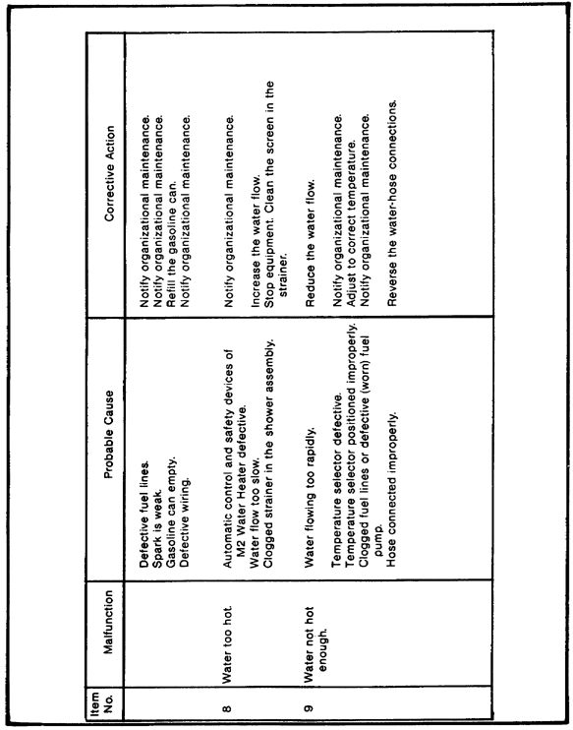
FIGURE 8. TROUBLESHOOTING TABLE, CONTINUED.

35
Lesson 3/Learning Event 2

LEARNING EVENT 2:
DESCRIBE OPERATOR CORRECTIVE
MAINTENANCE ON THE PUMP-UNIT ASSEMBLY

In the previous learning event, we discussed the corrective actions to be taken after the probable cause has been identified. Some of the corrections are self-explanatory, some are not. In this learning event we will describe some of these actions in greater detail as they pertain to the pump-unit assembly.

Operator preventive maintenance is limited to cleaning the pump and piping with hot, soapy water, then rinsing with clear water. Paint the exterior surface as required.

NOTE

All the procedures described can be done at the operator level of maintenance.

The following procedures cover operator maintenance of the pump-unit assembly and related components.

Maintenance of the Pump-unit Assembly, Control Panel. Maintenance of the control panel can be performed using the following steps.

Step 1. Wipe all switches and gages with a lint-free cloth. Clean the control panel with a cloth and dry-cleaning solvent (SD).

Step 2. Inspect all switches for loose parts or damaged wire leads. Inspect the gages for cracked dials and loose or sticking pointers. See that the nameplates and the starting procedures plate are legible and fastened to the panel. See that the panel is tightly fastened to the frame. See that the tubing, wire leads, hoses, and tachometer shaft are connected properly to the instruments or controls at the back of the panel, as well as at their other terminals. Inspect all the valve controls for ease of operation.

Step 3. If the fuze at the back of the control panel is burned out or missing, replace with the spare fuze. Then replace the spare fuze with a new fuze.

Step 4. If the generator warning light bulb does not light replace it. Unscrew the green lens and bezel as a unit from the light base. Press in on the exposed bulb gently with the thumb and release quickly. This spring action should release the bulb. (Or, stick some masking tape against the bulb and pull the bulb from the socket.) Insert the new bulb in the socket. Fasten the bulb in place by screwing the green lens and bezel into the light base.

36

Lesson 3/Learning Event 2

Step 5. Lubricate valves No. 1, 2, 3, 4, and tank-drain valve in accordance with LO-3-4230-209-12.

Maintenance of the Fuel Tank (Figure 9 on Page 38). Maintenance of the fuel tank can be performed by using the following steps.

WARNING

Inspect the fuel tank interior in daylight. If the fuel tank must be inspected at night, use a vapor-resistant light.

Step 1. Clean the external surfaces of the fuel tank with dry-cleaning solvent (SD). Remove the fuel-tank cap and lift out the filler neck with meshed screen. Remove any residual matter caught in the meshed screen. Replace the fuel-tank cap and lock it in place. Tighten the finger nut to shut off the fuel line. Loosen the thumbscrew, swing the bail to one side, and remove the sediment bowl. Remove the deposits from the sediment bowl and the filter. Replace the gasket. Set the sediment bowl and filter in the bail and tighten the thumbscrew. Loosen the finger nut. Make certain that the sediment bowl does not leak.

Step 2. Inspect the fuel tank for leaks, broken welds, or other damage. See that the straps that support the fuel tank are fastened through the frame and tightened by nuts. See that the fuel shut-off valve and the fuel hoses do not leak. Inspect to see that the fuel-level transmitter electrical leads are fastened at their respective terminals on top of the fuel tank.

Step 3. If the fuel tank, cap, pad, hoses, or shut-off valve must be repaired or replaced, notify organizational maintenance personnel.

Maintenance of the Gasoline Engine. Maintenance of the gasoline engine can be performed by using the following steps.

Step 1. See that the engine is fastened securely to the engine mounts. See that the two mufflers are installed and that the exhaust pipe extensions have been installed. Check for burned out fuzes. See that the tachometer cable and the electrical wires and cables are installed. See that the fuel line is installed on the carburetor, is tight, and does not leak. To perform this check, you must remove the top shroud. Check that the battery ground strap is fastened to the flywheel housing and the battery positive cable is connected to the starter solenoid.

Step 2. See that the engine is lubricated. See that the engine crankcase is filled with 4 1/2 quarts of oil, by pulling the oil-gage rod to check that the crankcase oil level is satisfactory. If the oil level is below the LOW mark add oil before operating the engine. Do NOT fill above the FULL mark.

37

Lesson 3/Learning Event 2

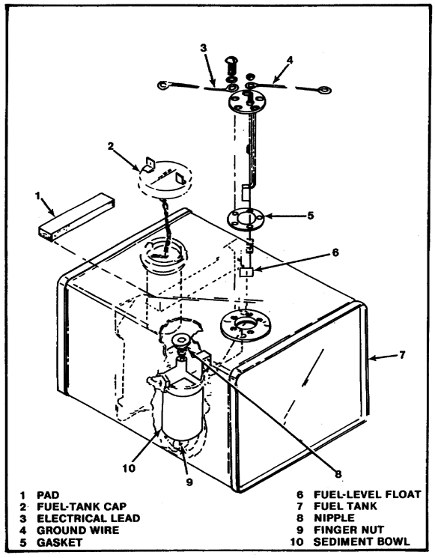
FIGURE 9. FUEL TANK, EXPLODED VIEW.

38

Lesson 3/Learning Event 2

Maintenance of the Drive Belts. To adjust the drive belts, perform the following steps.

Step 1. Remove the tensiometer from the toolbox and check to see that it is clean and serviceable.

Step 2. Set one O-ring at the 3/8-inch mark, and the other O-ring at the 0-pound mark against the sleeve. Put the small end of the tensiometer against one of the four drive belts, halfway between the engine and pump pulleys (figure 10). Press down on the tensiometer until the O-ring at the 3/8-inch mark touches the belt next to it. Remove the tensiometer and read the position of the second O-ring which was moved down the scale by the sleeve. The O-ring should be between the five to seven-pound mark for correct belt tension.

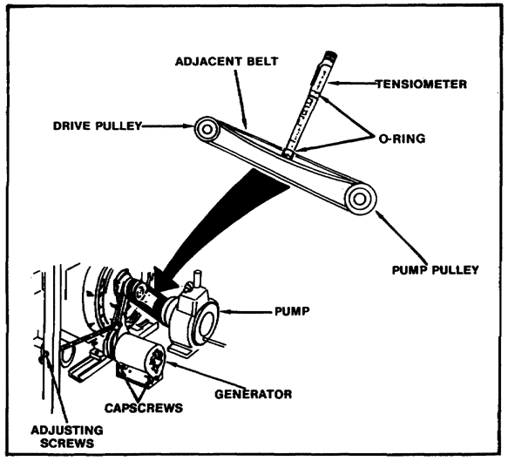
FIGURE 10. CHECKING TENSION OF DRIVE BELTS.

39

Lesson 3/Learning Event 2

If the belt tension is not between five to seven pounds, loosen the engine mounting bolts to move the engine. If the belt tension is more than five to seven pounds, move the engine toward the pump. If less than five to seven pounds, move the engine away from the pump. You may have to check the belt tension several times before you have the right belt tension.

Since the generator has only one belt, you will not be able to use an adjacent belt as a reference. Place a straight edge (a wrench, ruler, or other straight object) over the engine and generator pulley to use as a reference line. Proceed as you did when checking the drive-belt tension.

Since there is a generator-belt adjusting screw, adjusting the belt tension of the generator belt is somewhat easier than adjusting the drive belts. For the correct belt tensions, the O-ring should be at the five- to seven-pound mark. If the belt tension is not right, loosen the locknut on the belt adjusting screw, and the two capscrews on the generator (figure 11). Turn the adjusting screw clockwise to increase belt tension and counterclockwise to loosen belt tension. You may have to check a couple of times until you get the right belt tension. Tighten the generator capscrews and the belt adjusting screw locknut.

Maintenance of the Hoses. Maintenance of the hoses is performed by using the following steps.

Step 1. Flush the hoses with hot water.

Step 2. Clean the swivel couplings with dry-cleaning solvent (SD).

Step 3. Inspect and replace gaskets as necessary.

Step 4. Wash the exterior of the hoses with hot, soapy water.

Step 5. Dry all parts thoroughly.

Step 6. Inspect the hoses for leaks, breaks, or other damage. Inspect the swivel couplings for worn or damaged threads. Report a defective discharge hose to organizational maintenance personnel.

Maintenance of the Battery. Maintenance of the battery is performed by using the following steps.

Step 1. Clean the battery with a dry cloth and wire brush. If the battery is corroded, clean it with a brush dipped in a solution of bicarbonate of soda and water. After the foaming action stops, flush the battery with clean water and wipe it dry with a clean cloth.

40

Lesson 3/Learning Event 2

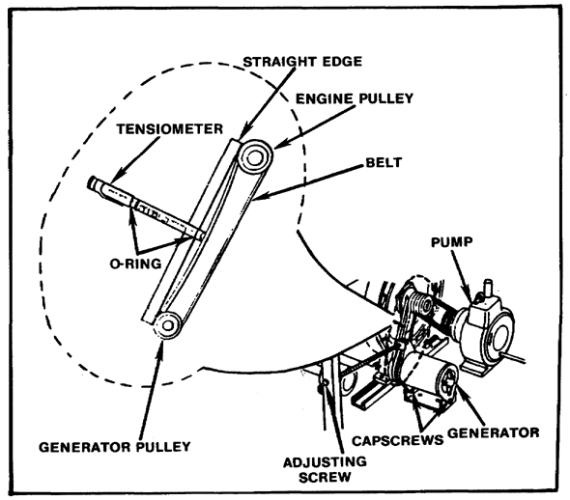
FIGURE 11. CHECKING GENERATOR BELT TENSION.

Step 2. If the top of the battery has cracked or blistered sealing compound, notify organizational maintenance personnel. See that the electrolyte level in each cell is approximately three-eighths of an inch above the separators. See that the ground strap is clamped to the NEG terminal on the battery. See that the POS cable is clamped to the frame and is fastened to the starter solenoid on the engine. See that the ground (NEG) strap is clamped to the skid and is bolted to the engine flywheel housing. See that the terminals on the battery are coated with automotive and artillery grease (GAA) to prevent corrosion. If the battery must be recharged or replaced, notify organizational maintenance personnel.

Maintenance of the Generator. Maintenance of the generator is performed by using the following steps.

41

Lesson 3/Learning Event 2

Step 1. Clean the exterior of the generator with a cloth dampened with dry-cleaning solvent (SD). Take care not to get any of the solvent inside the generator. Clean the V-type groove of the sheave with a cloth dampened with dry-cleaning solvent (SD).

Step 2. Inspect the generator for damage. See that no parts are missing, the electrical cable is fastened at both terminals, and the hardware fastening the generator to the skid is not loose or missing.

Step 3. If the generator must be repaired or replaced, notify organizational maintenance personnel.

WARNING

To avoid injury or electrical shock, keep the voltage regulator switch in the OFF position when the M2 Water Heater is not in use.

Maintenance of the Gun Assembly. Maintenance of the gun assembly is performed by using the following steps.

Step 1. Clean the hardened slurry or dirt from the gun assembly. Especially clean the hard-to-reach areas around the gun handle and the threads of the adapter. Use soapy water and a small brush to loosen the dirt. Rinse with clean water and dry.

Step 2. Notify organizational maintenance personnel if the gun assembly must be repaired or replaced.

Maintenance of the Nozzles. Maintenance of the nozzles is performed by using the following steps.

Step 1. Thoroughly clean all nozzles that have been used to spray liquids other than water. Use soapy water and a small brush to loosen dirt. Rinse with clean water. Dry all parts thoroughly.

Step 2. Inspect the three gaskets and the preformed packing for cuts, wear, and deformation. Replace defective gaskets or preformed packings.

Step 3. Disassemble the slurry nozzle and inspect or replace the retaining ring, retaining washer, headless straight pin, and adapter.

Step 4. Report other defects to organizational maintenance personnel.

42

Lesson 3/Learning Event 3

LEARNING EVENT 3:
DESCRIBE OPERATOR
CORRECTIVE MAINTENANCE ON THE
TANK-UNIT ASSEMBLY, M2 WATER HEATER,
AND PERSONNEL SHOWER UNIT ASSEMBLY

A detailed description of the procedures used by the operator to maintain the tank-unit assembly, M2 Water Heater, and the personnel shower unit assembly are provided in this learning event. This will enable the operator to perform corrective maintenance with a better understanding of what must be done.

Maintenance of the Tank-unit Assembly. Maintenance of the tank-unit assembly is performed by using the following steps.

WARNING

Before entering the tank-unit assembly, flush the interior of the tank with water to dissolve residual STB decontaminating agent. Drain the tank. Ventilate the interior of the tank with a stream of forced air to drive out the vapors. If entering the tank-unit assembly, insure that someone is stationed outside who will prevent the equipment from being moved, forklifted, hoisted, or used, and will come to your aid if necessary.

NOTE

Take a trouble light into the tank-unit assembly as an indication that someone is inside.

Step 1. Clean accumulations of hardened slurry from inside the tank-unit hopper blender, and the screen (figure 12 on page 44). Clean the tank liquid-level indicator so that its markings are legible. Immediately after slurry operation, clean the agitator with hot water, using a stiff brush to remove deposits of hardened slurry. Wash the interior of the tank and the inside and outside of the hoses with hot, soapy water rinse with hot water. Flush the foot-valve assembly with hot water wipe dry. Clean the outside of the tank-drain valve, tank-unit assembly, foot-valve assembly, and quick-disconnect coupling halves with dry-cleaning solvent (SD).

43

Lesson 3/Learning Event 3

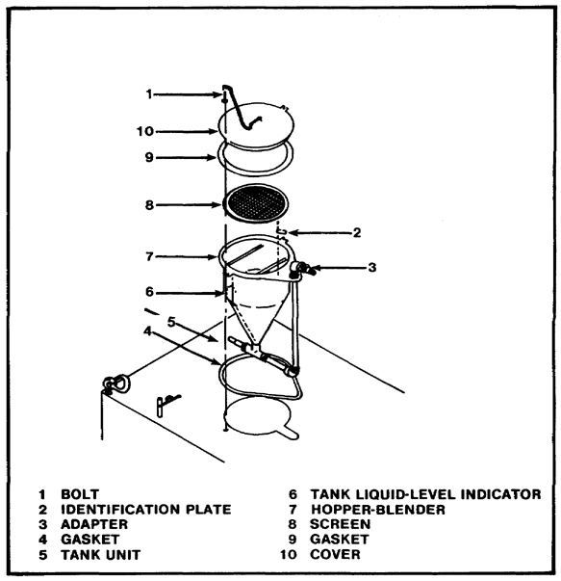
FIGURE 12. HOPPER-BLENDER ASSEMBLY.

Step 2. Inspect the exterior surfaces of the pipe and fittings for the following rust, corrosion, looseness, damage, cracks, out of round, broken parts, and deformation. See that the holes are not plugged with paint or other foreign matter. Clean the personnel shower assembly with hot soapy water rinse with clean water.

Step 3. If the personnel shower assembly must be repaired or replaced, notify organizational maintenance personnel.

44

Lesson 3/Learning Event 3

Maintenance of the M2 Water Heat. Maintenance of the M2 Water Heater will be performed using the following steps.

Step 1. Clean all parts in dry-cleaning solvent (SD).

Step 2. Inspect the fuel-supply and fuel-return lines and flare nuts for evidence of leaks or damage. Inspect the condition of the heat-reflective tape and rubber grommets. Inspect the condition of the stud fasteners and inspect for bent panels. Inspect all electrical components and wiring for defects; see that all connections are tight. Inspect the condition of the protective plug, protective cap, and dust cap. Inspect the fuel filter shell for evidence of leaks. While the M2 Water Heater is operating, inspect for evidence of steam leaks around the refractory gasket between the firebox and the end of the boiler. If the fuel filter shell leaks or the fuel filter must be replaced, notify organizational maintenance personnel.

Step 3. If the heat-reflective tape or rubber grommets must be replaced, notify organizational maintenance personnel. Replace the gaskets in the water hose, if required.

45

Lesson 3/Practice Exercise

PRACTICE EXERCISE FOR LESSON 3

Instructions

You have just finished reading the instructional material for Lesson 3. This lesson covered operator corrective maintenance of the M12A1 PDDA. It is now time to check your understanding of the lesson. This is done by completing the practice exercise below. All of the questions are multiple-choice and are intended to measure your understanding of the procedures used in performing the task. There is only one correct answer to each question. Try to answer all of the questions without referring to the lesson material.

When you have completed all of the questions, turn the page and check your answers against the correct responses. Each correct response is referenced to specific portions of the lesson material so that you can review any questions you have missed or do not understand. When you have completed your review, continue to the next lesson.

1. What must the operator do, once a problem is identified?

a. Perform repairs.
b. Perform a service.
c. Identify the probable cause.
d. Notify organizational maintenance.

2. Leakage around the refractory gasket indicates a problem with the

a. shower assembly.
b. pump unit.
c. tank unit.
d. M2 Water Heater.

3. What must be done prior to entering the tank unit?

a. Inspect the tie-downs.
b. Flush the tank.
c. Close the drain valve.
d. Install the hopper assembly.

4. A probable cause of an overheating pump is

a. pump is worn.
b. pump drive pulley is loose.
c. pump mountings are loose.
d. drive belt is worn.

46

Lesson 3/Practice Exercise

5. Which of the following CANNOT be repaired by the operator?

a. Shut-off valve
b. Belt tension
c. Removing deposits from the sediment bowl
d. Worn nozzle gaskets

6. If the top of the battery is cracked or blistered,

a. reseal the top.
b. change the battery.
c. remove some of the electrolyte.
d. notify organizational maintenance.

47

Lesson 3/Practice Exercise Answers

ANSWER SHEET FOR PRACTICE EXERCISE

Lesson 3

1. c (Refer to Learning Event 1)
2. d (Refer to Learning Event 3)
3. b (Refer to Learning Event 3)
4. a (Refer to Learning Event 1)
5. a (Refer to Learning Event 2)
6. d (Refer to Learning Event 2)

48

Lesson 4

LESSON 4
DESCRIBE ORGANIZATIONAL CORRECTIVE
MAINTENANCE OF THE M12A1 PDDA

TASK

Describe organizational corrective maintenance of the M12A1 PDDA.

CONDITIONS

Given information about the procedures for performing organizational troubleshooting and organizational corrective maintenance on the pump-unit assembly, tank-unit assembly, personnel shower unit assembly, and the M2 Water Heater, including subcomponents of these assemblies.

STANDARDS

Demonstrate competency of the task skills and knowledge by responding to the multiple-choice test covering the procedures for organizational trouble-shooting and performing organizational corrective maintenance on the pump-unit assembly, tank-unit assembly, personnel shower unit assembly, and the M2 Water Heater, including subcomponents of these assemblies.

REFERENCES

TM 3-4230-209-12
TM 3-4230-209-20&P
TM 3-4410-201-12
TM 5-2805-259-14

49

Lesson 4/Learning Event 1

LEARNING EVENT 1:
DESCRIBE TROUBLESHOOTING OF THE
M12A1 PDDA AT ORGANIZATIONAL LEVEL

Previously we have discussed the maintenance responsibilities of the operator. In this learning event we will discuss the organizational level of maintenance. Operator repairs are more or less of the quick-fix variety. The organizational level of maintenance performs the more time-consuming and detailed repairs. Anything the operator is not authorized to repair will be referred to organizational maintenance. First, organizational maintenance personnel will receive a DA Form 2404 from the operator stating the problem or problems. Then, maintenance personnel at this level will use the same method to troubleshoot the M12A1 PDDA as the operator. Based on the malfunction, an inspection is performed to ascertain the most probable cause of the problem and then a corrective action is performed. As with the operator level some problems are not authorized to be repaired at the organizational level. When this happens, a DA Form 2404 is again initiated and submitted to direct support maintenance. To assist you in troubleshooting, the most common problems are listed in a troubleshooting table. This table (figure 13 on pages 51 through 53) shows the malfunction, probable cause of the problem and the corrective action that must be taken to repair the component. Use this table whenever you are required to troubleshoot the M12A1 PDDA at the organizational level of maintenance.

50

Lesson 4/Learning Event 1

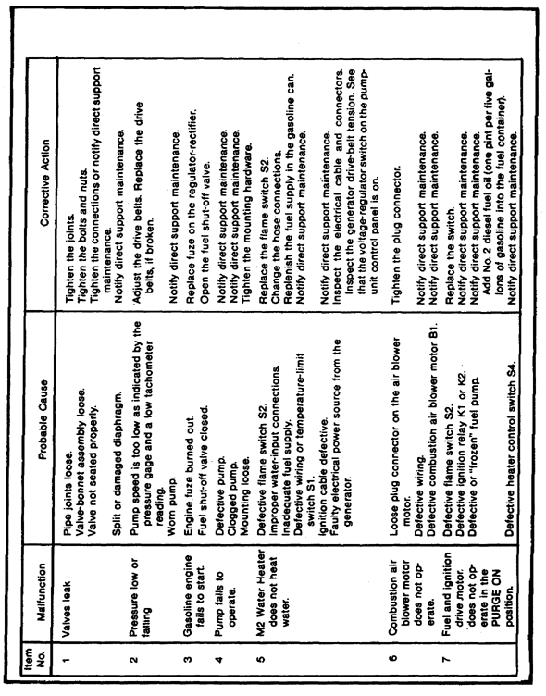
FIGURE 13. TROUBLESHOOTING TABLE.

51

Lesson 4/Learning Event 1

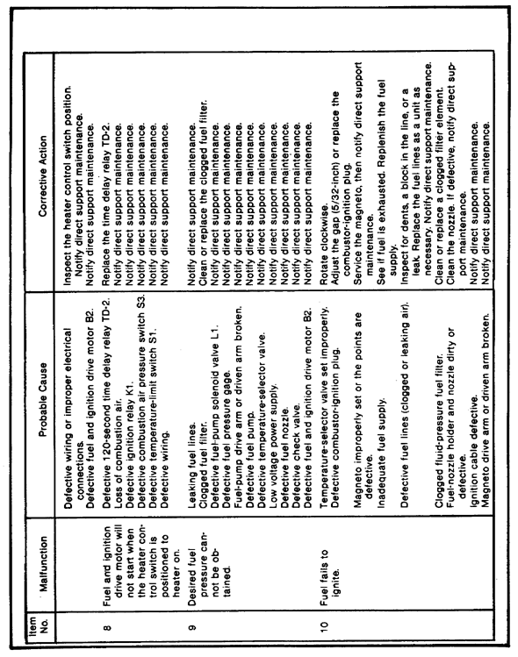
FIGURE 13. TROUBLESHOOTING TABLE, CONTINUED.

52

Lesson 4/Learning Event 1

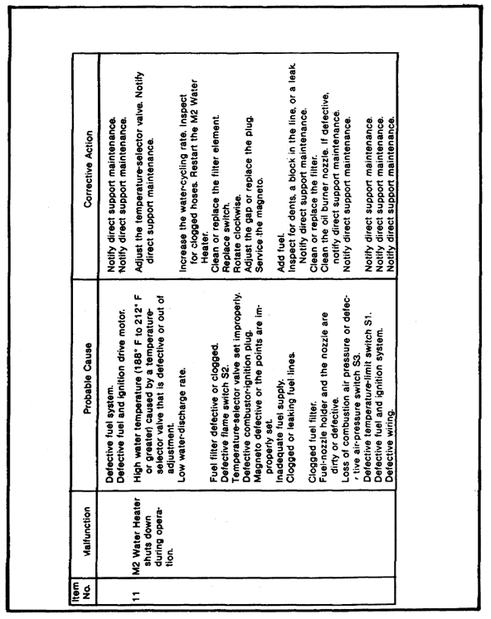
FIGURE 13. TROUBLESHOOTING TABLE, CONTINUED.

53

Lesson 4/Learning Event 2

LEARNING EVENT 2:
DESCRIBE ORGANIZATIONAL CORRECTIVE
MAINTENANCE OF THE PUMP-UNIT ASSEMBLY

Organizational corrective maintenance of the pump-unit assembly consists of the repair and/or replacement of selected components. We will discuss each component and the procedures used for the service required.

Pump. Pump housing repair will consist of replacement of the lubrication fittings and replacement of the pump breather. Use the following steps to replace the lubrication fittings.

Step 1. Use a wrench to remove defective fittings, by turning counter-clockwise.

Step 2. Use a wrench to install replacement fittings, by turning clockwise.

Step 3. Lubricate the pump.

The pump breather is a threaded hollow fitting with a cap. Service the breather using the following steps.

Step 1. Use a wrench to unscrew the pump breather.

Step 2. Clean the oil from the pump breather and reinstall. Replace the pump breather if the cap is missing or damaged.

Gasoline Engine. The only authorized repair to the engine at the organizational level is adjusting the governor to 3,850 RPM. Use
TM 5-2805-259-14 when this is required.

Control Panel Components. Prior to replacing control panel components, you must first gain access to the components. This is done in the following method.

Step 1. Remove the four clevis-lifting eyebolts on top of the pump unit.

Step 2. Remove the lid from the prime-detergent tank.

Step 3. Lift the top cover off the pump unit.

Step 4. Remove the lower right and left cover panels.

WARNING

Disconnect the battery's positive cable from the positive terminal before performing maintenance.

54

Lesson 4/Learning Event 2

Once access to the control panel components has been gained, the following items can be replaced.

Fuel quantity gage. Disconnect and tag the wires from the rear of the fuel quantity gage. Remove the nuts that fasten the gage to the mounting bracket. Remove the faulty gage from the mounting bracket and pull it through the front of the control panel. Position the new gage in the control panel. Fasten the gage to the mounting bracket at the rear of the control panel. Connect the wires to the terminals on the gage.

Fuel indicator switch. Disconnect and tag the wires from the rear of the fuel indicator switch. Remove the hex nut and bushing from the switch through the front of the control panel. Remove the faulty switch from the rear of the control panel. Position the new switch in the control panel. Install the bushing and the hex nut on the switch from the front of the control panel. Connect wires to the rear of the switch.

Oil-pressure switch. Disconnect and tag the wires from the rear of the oil-pressure switch. Remove the hex nut and bushing from the switch at the front of the control panel. Remove the faulty switch from the rear of the control panel. Position a new switch in the control panel. Install the bushing and hex nut on the switch from the front of the control panel. Connect the tagged wires to the rear of the switch.

Oil-pressure gage. Disconnect and tag the wires from the rear of the faulty oil-pressure gage by pulling the plug connectors. Remove the nuts that fasten the gage to the mounting bracket. Pull the gage through the front of the control panel. Position the new gage in the control panel. Install the nuts to fasten the gage to the mounting bracket. Connect the tagged plug connectors to the socket connectors on the gage.

Generator warning light. Disconnect and tag the wires from the rear of the generator warning light. Remove the hex nut and washer that fasten the light receptacle to the control panel. Pull the light through the opening and out the front of the control panel. Position the new light in the control panel from the front. Install the washer and hex nut on the light and draw the light up tightly against the back of the control panel. Connect the tagged wires to the rear of the light. Inspect to make sure that the bulb and lens are satisfactory.

Vacuum gage. Disconnect the tubing from the pipe nipple at the rear of the control panel beneath the gage. Remove the nut washers, spacers, and screws that fasten the gage to the control panel. Remove the bezel from the front of the control panel. Remove the gage from the back of the control panel and remove the elbow. Install the elbow on the new gage and position the new gage in the

55

Lesson 4/Learning Event 2

control panel from the back. Install the bezel on the gage from the front of the control panel. Install the screws, spacers, washers, and nuts to fasten the gage to the panel. Connect the tubing and pipe nipple to the elbow.

Pressure gage. Disconnect the tubing from the elbow and pipe nipple at the base of the gage on the back of the control panel. Remove the nuts, washers, spacers, and screws that fasten the gage to the panel. Remove the bezel from the front of the control panel. Remove the gage from the back of the control panel and remove the elbow from the gage. Connect the elbow to the new gage and position the new gage in the control panel from the back. Install the bezel on the gage from the front of the control panel. Install the screws, spacers, washers, and nuts to fasten the gage to the panel. Connect the tubing and pipe nipple to the elbow.

Tachometer-hourmeter. Unscrew the end of the flexible shaft from the back of the tachometer-hourmeter. Remove the nuts and lockwashers that fasten the tachometer-hourmeter to the mounting bracket. Remove the tachometer-hourmeter from the front of the control panel. Install the tachometer-hourmeter through the front of the control panel. Install the lockwashers and nuts to fasten the tachometer-hourmeter to the mounting bracket. Install the flexible shaft key in the back of the tachometer-hourmeter and tighten the nut.

NOTE

When replacing the tachometer-hourmeter, record the hours operated and serial number in the equipment logbook (TM
38-750). Record the new instrument reading and serial number in the equipment logbook.

Start-magneto switch. Disconnect and tag the wires from the back of the start-magneto switch. From the front of the control panel, remove the screw, bushing, and control knob from the switch stem. Withdraw the switch from the back of the control panel. Position the stem end of the new switch in the control panel. Install the bushing, knob, and screw on the switch stem from the front of the control panel. Connect the tagged wires to the rear of the switch.

Terminal board. Disconnect and tag the wires from the terminals. Remove the four screws, washers, and nuts that fasten the terminal board to the back of the control panel and remove the terminal board. Position the new terminal board against the back of the control panel and install the four screws, washers, and nuts to fasten the board to the panel. Connect the tagged wires to the terminals on the terminal board.

56

Lesson 4/Learning Event 2

Fuzeholder. Disconnect and tag the wires from the fuzeholder. Remove the two screws, washers, and nuts that fasten the fuzeholder to the back of the control panel. Remove the two fuzes and the fuzeholder. Position the new fuzeholder against the back of the control panel and fasten the two screws, washers, and nuts. To prevent a short circuit, install the hardware so that the screwhead is at the back of the panel and the washer and nut are at the front of the control panel. Connect the tagged wires to the terminals on the fuzeholder. Install two fuzes in the fuzeholder.

Voltage regulator. Disconnect the cable-plug connector from the socket connector at the bottom of the voltage regulator. Remove the nuts, washers, and screws that fasten the voltage regulator to the back of the control panel. Replace a faulty voltage regulator or voltage-regulator switch as a unit. Position the new voltage regulator against the back of the control panel and fasten it to the control panel with the nuts, washers, and screws. Aline it so that the toggle switch and the socket-receptacle connector fit through the holes in the control panel. Connect the cable-plug connector to the back of the voltage regulator.

Throttle. Loosen the setscrew fastening the throttle's wire to the adapter of the linkage on the engine. Loosen the screw, lockwasher, and nut that fasten the clamp to the bracket and remove the throttle. At the back of the control panel, remove the locknut that fastens the throttle against the control panel. Pull the throttle and wire out the front of the control panel. Retrieve the locknut from the back of the control panel. Remove the locknut from the new throttle. Install the wire end of the throttle in the front of the control panel. Install and tighten the locknut on the control wire from the back of the control panel. Insert the open end of the wire through the throttle clamp and throttle bracket, then into the throttle adapter on the gasoline engine. Fasten in place by tightening the screw, lockwasher, and nut. Tighten the setscrew. Check for proper operation of the engine.

Fuel shut-off valve. Close off the fuel supply by closing the thumbscrew at the base of the fuel tank. Disconnect both fuel hoses from the elbows at the back of the control panel and catch the residual fuel draining from the hoses. From the front of the control panel, remove the screw that holds the handwheel on the valve stem and remove the handwheel. Remove the nut that fastens the valve stem against the control panel. Remove the shut-off valve from the back of the control panel. Remove the two elbows and save them for reuse on the new valve. Install the elbows on the new valve. Insert the stem end of the new valve in the control panel. Fasten the stem to the control panel with the

57

Lesson 4/Learning Event 2

locknut. Install the handwheel on the valve stem and fasten the screw to hold it in place. Connect both fuel hoses to the elbows at the back of the valve. Open the fuel supply line at the base of the fuel tank and check for leaks. If the installation is leaktight, it is satisfactory.

Starting procedure plate and nameplates. Remove the drivescrews that fasten the plate to the control panel. Remove the plate. Attach the new plate on the control panel with drivescrews.

Valve handles and handwheels. Remove the handwheels of valves No. 1, 2 and 3 by removing the pin that connects the handwheel to the valve stem. Pull the handwheel off the valve stem. Remove the handles of the pump-drain valve and the prime-detergent tank valve by removing the nut washer, and handle from the extension rods. Installation is the reverse of removal.

Battery. A battery that will no longer hold a charge will be replaced. Use the following removal and installation procedures to change an unserviceable battery.

Removal. Remove the lower left front panel by turning the turnlock fasteners one-quarter turn. Remove the panel. Disconnect the positive cable from the battery POS terminal. Disconnect the ground strap (negative) from the battery NEG terminal. Remove the self-locking nut and washer from the two battery-retaining hook bolts and remove the battery bracket from the top of the battery. Use the plastic rope on the battery to remove it from the pump unit. Remove the battery pad from the pump unit. Clean the battery, bracket hook bolts, and the pad, if necessary, by using baking soda in water and a brush. Rinse with clear water. Remove the battery cables and clean them. Replace the battery cables, if necessary.

Installation. Position the battery pad through the two battery-retaining hook bolts. Position the POS terminal end of the battery nearest the pump. Position the battery bracket and retaining hook bolts on top of the battery. Install the washers and self-locking nuts on the two retaining hook bolts. Connect the battery negative cable to the battery (NEG) terminal. Connect the positive cable to the battery (POS) terminal. Coat terminals with GAA to prevent corrosion and block moisture; then tighten the terminal connections. Position the lower left front panel on the pump unit. Fasten the panel by turning the turnlock fasteners one-quarter turn.

Fuel Tank. Organizational maintenance repairs to the fuel tank are limited to repainting, replacing the fuel cap, fuel hose, sediment bowl, and the sponge-rubber pad that is cemented to the top of the fuel tank. The label on the bonding adhesive contains instructions for bonding the sponge-rubber pad to the fuel tank. The pad prevents the cover of the pump-unit assembly from striking the fuel tank.

58

Lesson 4/Learning Event 2

Drive Belts. Organizational maintenance personnel are authorized to replace the drive belts. Use the following methods for the removal and installation of the drive belts.

Removal. Removal of the drive belts can be done by using the following steps.

Step 1. Turn the turnlock fasteners one-quarter turn and lift the lower right front and rear panels off the pump-unit assembly.

Step 2. Loosen the locknut that fastens the generator drive-belt adjusting bolt against the frame assembly. Screw the bolt counterclockwise until the drive belt on the generator pulley can be removed from the grooved pulley. Remove the drive belt from the generator-driven pulley. (Remove the four pump drive belts (step 3 below) before removing the generator drive belt from the engine-driven pulley.)

Step 3. Loosen the two lockscrews that fasten the gasoline engine to the engine No. 1 mount (Engine No. 1 mount is next to the drive belt end of the engine.) Screw the adjusting bolt counterclockwise until the pump drive belts on the engine-driven pulley can be removed from the grooved pulley. Remove the set of four drive belts from the engine-driven pulley and the pump-driven pulley. Remove the generator drive belt from the engine-driven pulley.

NOTE

If one drive belt is defective, replace all drive belts with a new set.

Installation. Installation of the drive belts can be done using the following steps.

Step 1. Loop the generator drive belt in the groove of the drive pulley that is next to the driver-pulley adapter.

Step 2. Loop the drive belt around the generator-driven pulley.

Step 3. Loop the set of four drive belts in the grooves of the pump-driven pulley.

Step 4. Adjust the pump drive belt tension.

Step 5. Adjust the generator drive belt tension.

Step 6. Position the lower right rear panel and the lower right front panel on the pump-unit frame and fasten by turning the turnlock fasteners one-quarter turn.

59

Lesson 4/Learning Event 2

Discharge Hoses. If the discharge hose requires repair (other than the replacement of gaskets), replace it as a unit. To replace the hose, remove the gun assembly and adapter from the outlet end of the discharge hose. Unreel the discharge hose from the hose reel. Disconnect the inlet end of the hose from the hose-reel connection. Then notify direct support maintenance personnel.

Nozzles. Nozzles that cannot be repaired by replacing the gaskets and preformed packings will be sent to direct support maintenance.

Gun Assembly. The gun assembly can be disassembled to replace the ball valve assembly. Perform the following steps and use figure 14 on page 61 as a guide to repair the ball valve.

CAUTION

Do not attempt to remove the body cap by using a wrench; it will permanently damage the body cap. The body cap has wrench flats on its surface. However, it is not threaded into the body. Two dowel pins hold the valve body in place.

NOTES

The gun repair kit(TM 3-4230-209-20&P) is actually a ball valve repair kit. (Repair items 2, 3, 6, 7 and 15, A, figure 14). The prime-detergent valve and the pump-drain valve are different types of valves.

Instructions in steps 1 through 7 give repair instructions for the ball valve shown in A, figure 14.

Instructions in steps 8 through 12 apply only to ABC-M12A1 Decontaminating Apparatuses manufactured after 1969 by
All-Bann. These apparatuses have the ball valve shown in B, figure 14.

Step 1. Use a 1/8-inch straight-shank punch (or a 1/16-inch punch) and a hammer to drive the two pins (13A, figure 14) out of the valve body (12).

Step 2. Pull the body cap (1) out of the valve body (12).

Step 3. Remove the O-ring (2), flat washer (17), retainer springs (3), shims, if present and retainer (4) from the valve body (12).

Step 4. Rotate the gun handle (8) until it is 90 degrees from the valve body (12) and tilt the body. The ball (16) will slide out of the valve body (12).

60

Lesson 4/Learning Event 2

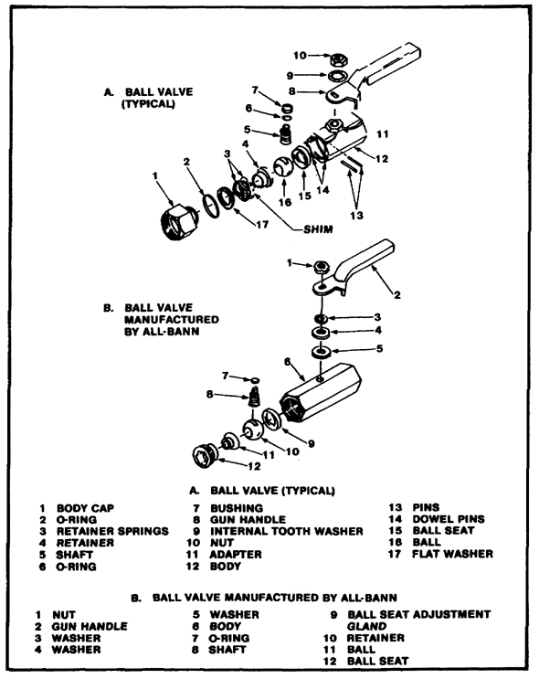
FIGURE 14. GUN ASSEMBLY BALL VALVES, EXPLODED VIEW.

61

Lesson 4/Learning Event 2

Step 5. Remove the nut (10) that fastens the shaft (5), washer (9), and gun handle (8) to the valve body (12). Remove the washer and the gun handle.

Step 6. Press the shaft through the adapter (11), and remove the shaft from the open end of the valve body. Remove the teflon bushing (7) and O-ring (6) from the shaft (5).

Step 7. Remove the ball seat (15) and adapter (11) from the valve body. Assembly is the reverse of disassembly. When required, shims are installed between the retainer springs (3). The collar on the body cap (1) must fit outside of the shoulder of the retainer (4) so the headless pins (13) can be installed.

Step 8. Remove the ball seat adjustment gland (9B). Rotate the retainer (10).

Step 9. Rotate the gun handle (2) 90 degrees from the valve body (6) and tilt the body. The ball (11) will slide out of the valve body (6).

Step 10. Remove the nut (1), gun handle (2), spring washer (3), flat washer (4), and nylon washer (5). Press the shaft (8) through the valve body (6). Remove the shaft (8) and O-ring (7) from the valve body.

Step 11. Remove the ball seat (12).

NOTE

The ball seat (12) and O-ring (7) are provided in the gun repair kit (TM 3-4230-209-20&P). If other parts are required to repair the ball valve, obtain them through cannibalization.

Step 12. Replace the ball valve if it cannot be repaired by using parts from the gun repair kit or cannibalized parts.

Step 13. Assembly is the reverse of disassembly. After the All-Bann valve is assembled, adjust it to prevent leakage (a and b below).

a. Adjustment. If fluid leaks between the body and handle of the valve, tighten the nut above the handle. Tighten the nut only enough to stop a leak or until resistance to handle movement is felt. DO NOT OVERTIGHTEN.

b. Gland adjustment. If fluid leaks through the body of the valve, tighten the ball valve seat. First remove the adapter to expose the ball seat adjustment valve. Tighten the gland only enough to stop leakage. As the gland is tightened, increased resistance to gun handle movement will be felt. Do not overtighten the adjustment gland. Then reassemble the ball valve.

62

Lesson 4/Learning Event 2

Reassembling Gun. Position the gun handle on the assembled ball valve so that the handle is in line with the valve body as shown in A, figure 14 on page 61. Clean and dry the threads on the ends of the ball valve. Reassemble the ball valve to make up the gun assembly by positioning the ball valve on the adapter and screwing it on the upstream end of the ball valve. Connect the extension pipe and the appropriate nozzle to the ball valve. Tighten all connections just enough to prevent leakage at the joints. Do not overtighten.

63

Lesson 4/Learning Event 3

LEARNING EVENT 3:
DESCRIBE ORGANIZATIONAL
CORRECTIVE MAINTENANCE ON THE
TANK-UNIT ASSEMBLY, PERSONNEL SHOWER
UNIT ASSEMBLY, AND THE M2 WATER HEATER

The tank of the tank-unit assembly will not be repaired at the organizational level. All tank repairs, such as welding and valve replacement will be referred to direct support maintenance. All repairs to the suction and blender hoses (components of the tank-unit assembly) will also be referred to direct support maintenance. The only component of the tank-unit assembly that organizational maintenance personnel are authorized to repair is the foot valve. The foot valve (figure 15) can be disassembled at the organizational level and the valve (item 7) may be replaced if defective. Use the following method for repairing the foot valve.

NOTE

When using this method, refer to figure 15 on page 65.

Foot Valve Repair. Disassemble the foot-valve assembly (figure 15 on page 65) by removing three nuts and bolts. Use a 1/2-inch open-end wrench to separate the strainer halves from the foot-valve housing. Remove the bolt, washer, and nut that fasten the flat-washer valve reinforcement plate and valve together. Replace the valve if necessary. Assemble the pieces of the foot-valve assembly by positioning the valve reinforcement plate against one side of the valve. Then place the flat washer on the opposite side of the valve. Fasten these parts together with a bolt, washer, and nut. Tighten the parts wrenchtight. Lay the strainer halves on the bench with the bolt holes alined. The strainer half must be on the bottom. Lay the assembled valve as a unit flat across the strainer half with the three bolt holes. Aline the three bolt holes of the foot-valve housing and the two strainer halves and fasten these parts together by using the three bolts and nuts. Tighten the nuts wrenchtight. Inspect to see that the valve flaps open and close when inverted.

The personnel shower unit assembly will not be repaired at the organizational level. Components with damaged threads or couplings will be turned in to direct support maintenance for repair or replacement.

At the organizational level, the M2 Water Heater is authorized repairs to the control and cover panels, main electrical power cable, fuel hose, water hose, fuel system, ignition system, and low-pressure heating boiler. Repair procedures for each component and system are described on page 66.

64

Lesson 4/Learning Event 3

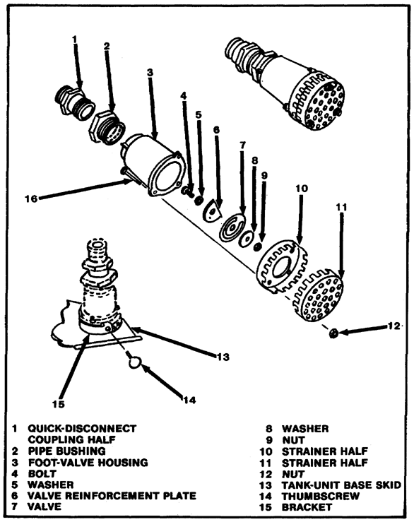
FIGURE 15. FOOT-VALVE ASSEMBLY, EXPLODED VIEW.

65

Lesson 4/Learning Event 3

Control Panel. Tighten any loose hardware on the electrical terminals and any loose fittings on the fuel-pressure lines. Replace defective time delay relays (figure 16 on page 67) TD-1 and TD-2. Loosen the tube clamp that fastens the relay in the tube socket. Remove the defective relay. Replace with the proper time delay relay. Plug the relay into the tube socket and tighten the tube clamp. Then install the control box cover plate.

Cover Panels. Repairs of the cover panels consist of painting (TM 9-213), restoring markings, replacing the heat-reflective tape, straightening bent or deformed panels, or replacing individual cover panels as units. If the turnlock-fastener assemblies are broken or damaged; notify direct support maintenance personnel.

Main Electrical Power Cable (Figure 17 on Page 68). If inspection reveals that the electrical power cable is defective, remove and replace as a unit as described below.

• Disconnect the ground wire terminal lug from the ground lug. Disconnect the black (or hot) power wire terminal lug from terminal A2 of ignition relay K1. Unscrew the stuffing tube from the pipe nipple. Slide the washer up the cable and work the rubber gasket out of the pipe nipple with your fingers. Carefully pull the main electrical power cable terminal lug end through the adapter in the top front plate. Separate the washer, rubber gasket and stuffing tube. Notify direct support maintenance personnel to repair the defective cable. Installation of the power cable is the reverse of removal.

Fuel Hose (Figure 18 on page 69). Remove and replace the fuel hose, electrical insulation tape, or the plug gaskets if required.

NOTE

If the ground wire's soldered ends are broken, notify direct support maintenance personnel.

Fuel and Water Lines. Remove a damaged fuel or water line by disconnecting the flare nuts from both ends of the line. Clean the line of the obstruction or replace the damaged line with a new one. Direct support maintenance personnel are authorized to repair dented lines or fabricate new lines. Install a fuel or water line by connecting the flare nut on each end of the line and drawing the flared nuts tight.

Fuel System. Clean the fuel filter shell and head with solvent and dry thoroughly. Replace the fuel filter element if required.

66

Lesson 4/Learning Event 3

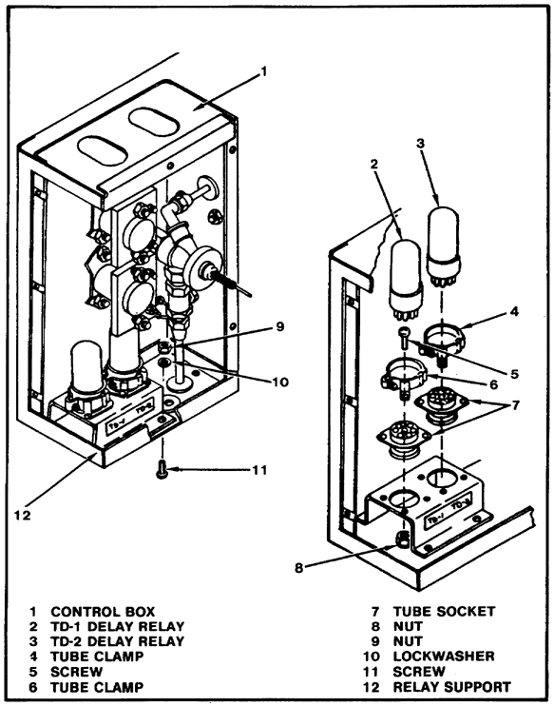
FIGURE 16. TIME DELAY RELAYS.

67

Lesson 4/Learning Event 3

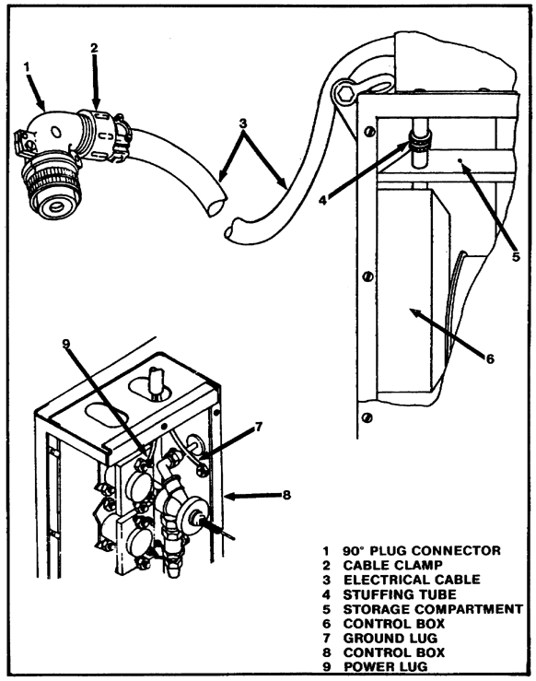
FIGURE 17. MAIN ELECTRICAL POWER CABLE.

68

Lesson 4/Learning Event 3

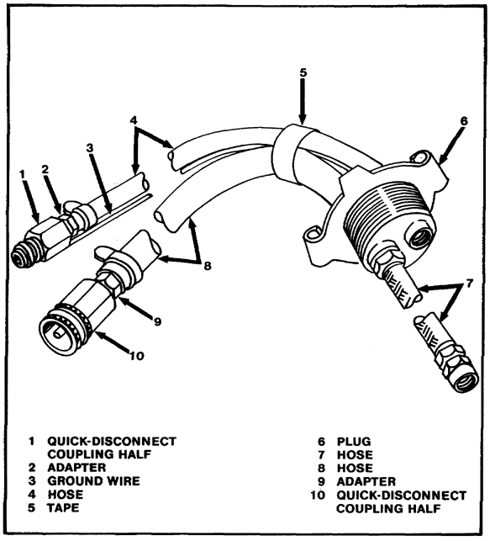
FIGURE 18. FUEL-HOSE ASSEMBLY.

WARNING

When removing the fuel filter shell, do not smoke or use an open flame in the vicinity. Take care to avoid spilling excessive amounts of fuel. Wipe up all spilled fuel.

69

Lesson 4/Learning Event 3

NOTE

Direct support maintenance personnel may have to help replace the fuel filter element. Organizational maintenance personnel do not have proper tools to remove the cover nut of the fuel filter with the piping arranged as it is. If the fuel filter element must be replaced, organizational maintenance personnel must remove the tubing first.

Ignition System. Ignition system repair will consist of cleaning and regapping the magneto points by the following method.

• Disconnect the electrical ignition cable from the magneto and remove the end cap by removing four screws. Carefully separate the end cap and gasket from the magneto frame. Inspect the contacts for evidence of burning, pitting, or wear. Use a contact point dresser to dress down the contacts. Rotate the drive arm until the breaker arm is riding on the high surface of the cam. Insert a feeler gage between the contact points and check that the gap is between 0.015 and 0.018 inch. Loosen and tighten screws until the gap is correct. If other maintenance is necessary, notify direct support maintenance personnel. Position the end cap and gasket on the frame and fasten them in place with the four screws and lockwashers. Connect the electrical ignition cable to the magneto.

Low Pressure Heating Boiler. Boiler components that are authorized repair by organizational maintenance personnel are the flame switch, nozzle holder, ignition plug and spark arrester. Each item and repair procedures are described below.

Flame switch (SPST thermostatic). Remove the five screws and washers that fasten the side exhaust insulation cover to the exhaust insulation cover and cabinet frame. Remove the three nuts and washers that fasten the cover to the boiler and remove the cover. Disconnect the electrical wiring from the flame switch. Using a 5/8-inch open-end wrench, remove the flame switch from the exhaust flue. Installation of the flame switch is the reverse of removal.

Nozzle holder and ignition plug (figure 19 on page 71). Remove the cover plate. Disconnect the nozzle-valve line and the combustion-return line from the nozzle holder. Rotate the combustor nozzle holder to clear the holding bracket and remove the nozzle holder and combustor plate as a unit from the combustor chamber. Clean all parts thoroughly in dry-cleaning solvent. Examine all parts for cracks, breaks, obstructions, damaged threads, and

70

Lesson 4/Learning Event 3

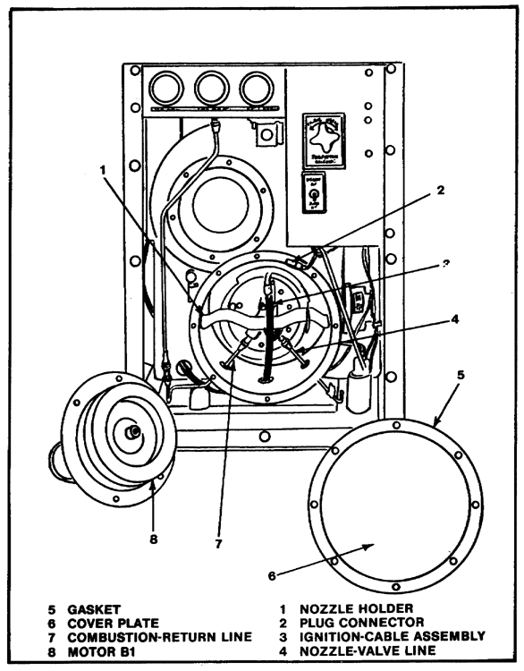
FIGURE 19. NOZZLE HOLDER AND IGNITION PLUG.

71

Lesson 4/Learning Event 3

deterioration. Measure the gap between the ignition-plug electrode and the combustor-plate electrode. The gap should be 5/32 of an inch. If the ignition plug is unserviceable for other reasons, replace with a new ignition plug.

Gap the plug 5/32 of an inch by bending the electrode on the combustor plate. Inspect the nozzle holder as a unit. Replace the pressure-atomizing oil-burner nozzle if it is defective or unserviceable. Installation of the nozzle holder, ignition plug, combustor plate, and combustor assembly is the reverse of removal.

Spark arrester. Remove the two nuts, washers, and screws at each end of the spark arrester. Lift the spark arrester out of the stack. If inspection reveals the spark arrester is damaged, repair as required. Installation is the reverse of removal.

72

Lesson 4/Practice Exercise

PRACTICE EXERCISE FOR LESSON 4

Instructions

You have just finished reading the instructional material for Lesson 4. This lesson covered the procedures for estimating fuel requirements and supervising stockage at the platoon level. It is now time to check your understanding of the lesson. This is done by completing the practice exercise below. All of the questions are multiple-choice and are intended to measure your understanding of the procedures used in performing the task. There is only one correct answer to each question. Try to answer all of the questions without referring to the lesson material.

When you have completed all of the questions, turn the page and check your answers against the correct responses. Each correct response is referenced to specific portions of the lesson material. You can review any questions you have missed or do not understand. When you have completed this practice exercise, you should review all of the subcourse material before starting the posttest.

1. Organizational maintenance to the tank-unit assembly will consist of repair to the

a. welds.
b. skids.
c. tank valve.
d. foot valve.

2. In order to remove the main electrical power cable, you must first

a. disconnect the ground wire.
b. notify direct support maintenance.
c. separate the washer and gasket.
d. remove the pipe nipple.

3. How will organizational maintenance personnel be made aware of problems with an M12A1 PDDA?

a. Troubleshooting.
b. The operator's DA Form 2404
c. Notification from the company commander
d. The M12A1 PDDA is overdue for service

73

Lesson 4/Practice Exercise

4. What must be done by organizational maintenance personnel after servicing the magneto?

a. Replenish the fuel supply.
b. Return the M12A1 PDDA to the operator.
c. Notify direct support maintenance.
d. Lubricate the pump unit.

5. Which of the following is an authorized repair to the gasoline engine?

a. Adjusting the magneto
b. Replacing the carburetor
c. Adjusting the governor
d. Replacing the spark plug leads

6. A pipe nipple connects the tubing to which gage?

a. Fuel
b. Oil
c. Generator
d. Vacuum

74

Lesson 4/Practice Exercise Answers

ANSWER SHEET FOR PRACTICE EXERCISE

Lesson 4

1. d (Refer to Learning Event 3)
2. a (Refer to Learning Event 3)
3. b (Refer to Learning Event 1)
4. c (Refer to Learning Event 1)
5. c (Refer to Learning Event 2)
6. d (Refer to Learning Event 2)

76

